CTV Guide

Comprahensive guide to operation and maintinance of CTV

George Burns

2024

# Chapters

## Introduction

* 1. Lesson plan
  2. Risk assessment
  3. Contacts

## Operation

* 1. Safety
  2. What to bring
  3. How to begin
  4. Software arguments
  5. Inventory

## Troubleshooting

* 1. Electronics issues
  2. Mechanical issues
  3. Software issues

## Manufacture

* 1. Step by step guide
  2. Design philosophy.
  3. Print files and drawings

# 1. Introduction

Capture the Volcano (CTV) is an interactive outreach session for students in years 8- 13. It aims to teach students the fundamentals of earth observation and coding using an interactive lesson plan and earth observation simulation game.

## Lesson plan

1. IMPORTANT Make sure to brief all parties on health and safety before engaging in any activity, in the form of sharp edges (wires, resistors, LEDs), tripping hazards from computer connections, spillages into electrical equipment, electrical discharge hazards from the robotic interactive game (rig) and crushing hazards from the rig.
2. Explain the UoBSat program, make sure to mention collaboration between students and academics, and mention student participation. Detail PROVE Pathfinder and its mission. This includes the definition of a “U”, contextualise the size of PROVE and detail its acronym.
3. Detail the motivation of PROVE, all scientific goals, with a special remark on the observation of ash clouds for safety purposes. Briefly explain the concept of ash cloud reconstruction.
4. Explain the concept of polar orbit and PROVE’s required orbit, briefly mention CONOPS and the stages of mission operation.
5. Talk about Fuego and its location and show a video of Fuego erupting.
6. Talk about testing at ESA.
7. Explain a breadboard.
8. Explain a microcontroller
9. Get students to perform the “Hello World” task on Arduino
10. Help students hook up the resistor and diode combination and explain how this can be used to simulate a volcano.
11. Give students time to create their functions/ code to turn off and on the LED
12. CTV activity.
13. Is this anything like life at a university? Talk about how the skills the students used and how they would be used at university.
14. Plug socials and feedback forms.

## Risk assessment

## Contacts

* Most recent engineer, George Burns: [lp21819@bristol.ac.uk](mailto:lp21819@bristol.ac.uk)
* Lucy Berthoud, Lead staff member for UoBSat: [lucy.berthoud@bristol.ac.uk](mailto:lucy.berthoud@bristol.ac.uk)
* Josh Hoole, CADE Lecturer and outreach contact: [josh.hoole@bristol.ac.uk](mailto:josh.hoole@bristol.ac.uk)
* Lisa McCormack, Outreach lead UoBSat: [pd22900@bristol.ac.uk](mailto:pd22900@bristol.ac.uk)
* Access and Inclusion Mailbox: <feng-access-inclusion@bristol.ac.uk>

# 2. Operation

## 2.1 Safety

When working with the rig there is a chance that motors will move, to ensure that motors do not move either, the disconnect power supply for the motors ($5V)$, ensure that the game program is not running or turn off Raspberry PI. It would be best if all these actions were performed before any mechanical components of the rig were worked on.

A non-trivial amount of current is fed into the Peltier modules, please ensure that the current to these Peltier modules is limited before operation and that if exposure to live wire with the Peltier is possible then the power source must be turned off/ disconnected.

Both motor drivers can build significant heat if they are not actively cooled. The fan provided should allow adequate cooling of both drivers, if at all the fan fails or is non-operational then caution should be taken when handling the motor driver

## 2.2 What to bring

For open days/ events with no teaching all that needs to be brought is the rig and a monitor/ TV, a mouse and keyboard, a power supply the joystick and hazard tape to corner off the rig.

For days with teaching the list of items that need to be brought is.

* Everything previously mentioned.
* Arduinos, enough for 1 per team.
* Resistors, in order of $100Ω$ to $100kΩ$.
* LEDs, any colour, with enough current rating for $\frac{5V}{100Ω}=0.05A$.
* Breadboards, enough for 1 per team.
* Jumper wires, to attach resistors and LEDs to Arduino.
* Laptops, enough for 1 per team, can be supplied by engineering outreach contacts (sec 1.3).
* Optional: All broken items, old mechanical models’ items that can be broken to use as examples

## 2.3 How to Begin

This section details the basic operation of the rig and its fundamental design. The rig is an x-y gantry system that uses stepper motors to control its position, this is interfaced using the GPIO and PWM pins on the Raspberry Pi (PI). The PI reads the input of the joystick a process described in *joystick.py* then uses the class and functions found in *stepper.py* to control the robot's motion. While doing this the PI also uses PyGame to display the game hub and relative information, the PI also runs a pseudo-random process that controls the on/off functions of the Peltiers. The control of the Peltiers can be switched from a PI random to the Arduino code designed by the students by attaching GND, 5V and the switch pin in the setup shown below.

DO A PHOTO Transition

|  |  |
| --- | --- |
|  |  |

For normal operation, the Peltiers can be controlled by the PI ensure that all the switches are all ON the Arduino’s can either be connected or disconnected depending on the situation.

Power the main board by supplying 12V (1A) and **A CURRENT LIMITED (1A) 5V SUPPLY** via the barrel jack connections via the power supply mentioned before do not turn the power supply on yet. Power the PI using the USB-C power adaptor, and attach the Keyboard, mouse, two cameras and joystick to the USB connections and finally the HDMI cable to the PI. Power the power supply and both channels should be green.

To start the game firstly open a terminal, run the following commands

$ sudo modprobe v4l2loopback

$ sudo thermapp

Once these have run **OPEN A NEW TERMINAL** and run the following commands

$ cd /Outreach

$ python3 main.py 100 1 5

This starts a game for 100 seconds, in the ground mode with 5 available pictures to be taken. Once the player countdown has expired or has used all the photos the game will display the amount of successful photos taken.

To adjust the temperature blah blah put it all here

## 2.4 Software Arguments

3 main software arguments are needed the syntax is shown below

$ python3 main.py x y z

Each is described below

|  |  |
| --- | --- |
| Argument | Meaning |
| x | The time that the game is running for, i.e if 100 the game will run for 100 seconds |
| y | What game mode is entered 1 for ground and 0 for space |
| z | How many photos does the user have, if 5 then the user will have 5 photos to take until the game is over, it is best to not go above 10 photos as you will start to encounter UI glitches at that level. |

## 2.5 Inventory

|  |  |  |  |  |  |  |  |  |  |  |
| --- | --- | --- | --- | --- | --- | --- | --- | --- | --- | --- |
| Parts | Number Needed | Number have | Order | Need | Price per | Price | Num per | After order | Part No | Datasheet |
| Rail holder | 4 | 4 | FALSE | 0 | x | x | x | x | x | X |
| Holder_bot_right | 1 | 1 | FALSE | 0 | x | x | x | x | x | x |
| Holder_top_left | 1 | 0 | FALSE | 1 | x | x | x | x | x | x |
| Holder_top_right | 1 | 1 | FALSE | 0 | x | x | x | x | x | x |
| Motor_holder_base | 1 | 0 | FALSE | 1 | X | X | x | x | x | x |
| Motor_holder | 2 | 0 | FALSE | 2 | x | x | x | x | X | x |
| Camera_holder | 1 | 1 | FALSE | 0 | x | x | x | x | x | X |
| 6m linear bearing | 2 | 2 | TRUE | 0 | x | x | x | x | x | X |
| 8m linear bearing | 4 | 4 | TRUE | 0 | x | x | x | x | x | x |
| M5x40 bolt | 32 | 13 | FALSE | 19 | 0.4696 | 23.48 | 50 | 18 |  | <https://uk.rs-online.com/web/p/socket-screws/0293353?gb=s> |
| M5 Nut | 32 | 0 | TRUE | 32 | 0 |  | 100 | 68 |  | <https://uk.rs-online.com/web/p/hex-nuts/0189585?gb=s> |
| Filed_rail_holder_bolt | 4 | 1 | FALSE | 3 |  |  |  | -4 |  |  |
| 8mm rail | 4 | 4 | TRUE | 0 |  |  |  | -4 |  |  |
| 6m rail | 2 | 2 | TRUE | 0 |  |  |  | -2 |  |  |
| 8mm bearing | 6 | 6 | TRUE | 0 |  |  |  | -6 |  |  |
| Rexroth M8 T nut | 16 | 0 | TRUE | 16 |  |  |  | -16 |  |  |
| M8x? bolt | 16 | 0 | TRUE | 16 |  |  |  | -16 |  |  |
| M2 nut | 16 | 16 | TRUE | 0 |  |  |  | -16 |  |  |
| M2x22 bolt | 16 | 82 | TRUE | -66 | 0.0731 | 7.31 | 100 | 84 |  | <https://uk.rs-online.com/web/p/machine-screws/1795690> |
| Motors | 2 | 3 | FALSE | -1 |  |  |  |  |  |  |
| motor_drivers | 2 | 2 | FALSE | 0 | 2 |  |  |  |  |  |
| Thermistor | 4 | 0 | TRUE | 4 | 15.84 | 3.96 | 1 | 1 |  | <https://uk.rs-online.com/web/p/thermistor-ics/0151237?gb=s> |
| Peltier | 4 | 4 | FALSE | 0 |  |  |  |  |  |  |
| Multiplexer | 8 | 0 | TRUE | 8 | 0.11 | 4.32 | 10 |  |  | <https://eu.mouser.com/ProductDetail/Vishay-Siliconix/DG9411EDL-T1-GE3?qs=fA06TrWLL4dRgZJpxr3dTQ%3D%3D> |
| PNP transistor | 4 | 0 | TRUE | 4 | 0.336 | 2.87 | 10 |  |  | <https://www.mouser.co.uk/ProductDetail/Central-Semiconductor/2N3905-PBFREE?qs=l7cgNqFNU1huTIE%2FlKXN1A%3D%3D&mgh=1&vip=1&srsltid=AfmBOoppLk67VuQ9ryTtSUEd1jdEywF2WozyOxBmrGAES2edhUZnP0j6cRg> |
| NPN transistor | 4 | 0 | TRUE | 4 | 0.406 | 4.06 | 10 |  |  | <https://www.mouser.co.uk/ProductDetail/Central-Semiconductor/2N2924-PBFREE?qs=u16ybLDytRYiihPlX6%252Bhcg%3D%3D> |
| Comparator | 16 | 0 | TRUE | 16 | 0.26 | 2.67 | 10 |  |  | <https://eu.mouser.com/ProductDetail/onsemi/LM258DR2G?qs=2OtswVQKCOF0y%252BvEODpnHw%3D%3D> |
| 10k pot | 16 | 0 | TRUE | 16 | 0.475 | 4.75 | 10 |  |  | <https://eu.mouser.com/ProductDetail/Amphenol/N6L30T3N-103-3030?qs=Rp5uXu7WBW%252B8ZM8WtY2TfQ%3D%3D> |
| 10k res | 60 | 0 | FALSE | 0 |  |  |  |  |  |  |
| NAND | 8 | 10 | TRUE | 0 |  |  |  |  |  | <https://www.mouser.co.uk/ProductDetail/Nexperia/74LVC1G08GW125?qs=me8TqzrmIYVtW9TtT8QUhw%3D%3D> |
| NOT | 4 | 10 | TRUE | -6 |  |  |  |  |  | <https://www.mouser.co.uk/ProductDetail/Texas-Instruments/SN74LVC1G14DCKR?qs=j%2FZo4ajzVJKuhrRdLjfZIw%3D%3D> |
| H-Bridge | 4 | 0 | TRUE | 4 |  |  |  |  |  |  |
| Switches |  | 0 | TRUE | 0 |  |  |  |  |  |  |
| Barral Jack | 2 | 0 | TRUE | 2 | 3.84 | 7.68 | 1 |  |  | https://uk.rs-online.com/web/p/dc-power-connectors/0476157?gb=s |
| Fan | 1 | 0 | TRUE | 1 |  |  |  |  |  |  |

# 3. Troubleshooting

## 3.1 Electronics Issues

* Turn it off and on again, turn the power supply off then remove the 5V USB-C connection to the PI will reset both the code and the Electronics

## 3.2 Mechanical Issues

## 3.3 Software Issues

* Reset the software by closing all the terminals, else reset the PI as described in 3.1
* If an error “camera is busy” when booting the main code simply run again this should solve the issue, else reset the software.

# 4. Manufacture

## 4.1 Step-by-step guide

All M6 Bolts can be tightened with $4mm$ star bit

M2 bolts can be fastened using an M2 wrench/ torque bit.

1. Start with the x bar and y bar and place at a right angle.   
     
   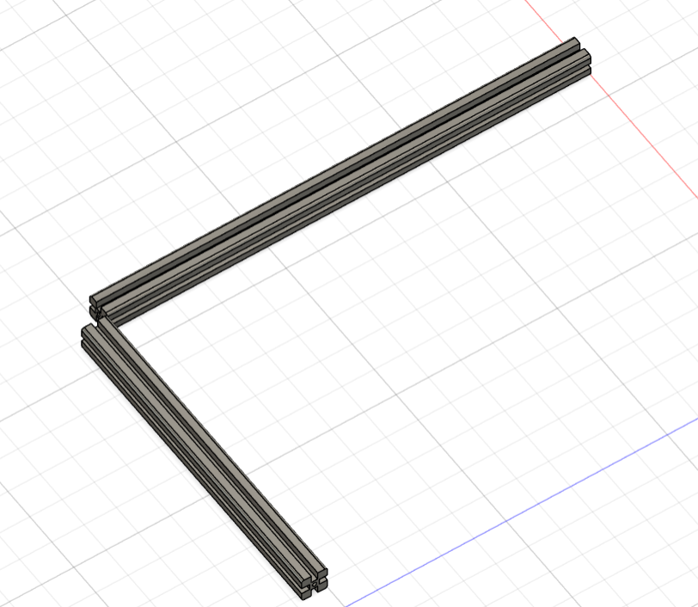
2. Use the corner cube to align at $90°$.

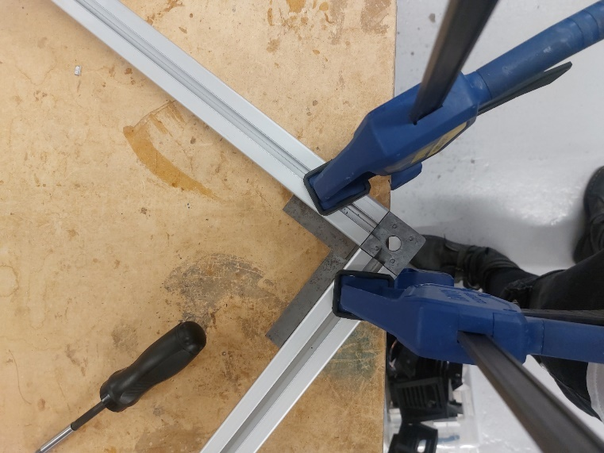

1. Screw in screw whilst checking for $90°$ alignment. Use clamps.
2. Place support place screws but do not tighten   
   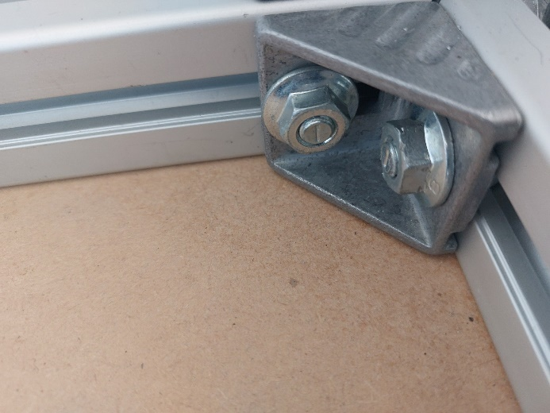
3. Once aligned tighten the support brace bolts while ensuring that the bars are aligned.
4. Place the leg on top of the current assembly and align it to $90°$.   
   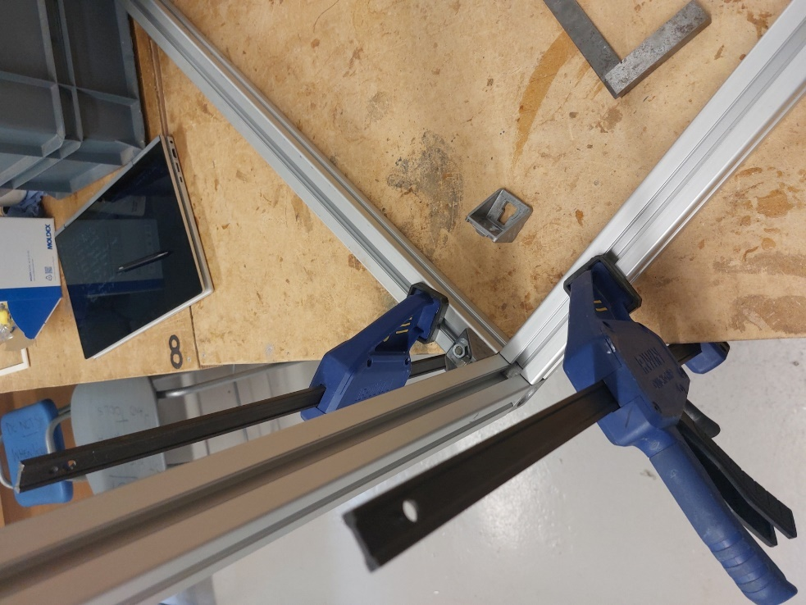
5. Screw in the supporting screw slowly until the leg is tight, ensuring that the leg stays $90°$ to the base.
6. Add alignment hinge and tighten bolts ensuring $90°$ alignment.
7. Repeat steps 1-9 for the other side.
8. Should have a structure equivalent to   
   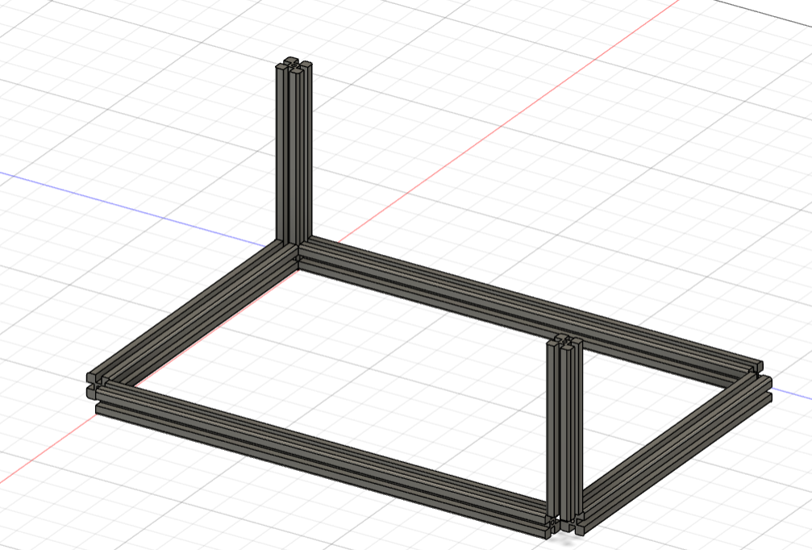
9. Place other legs and attach bolts to base cube. (Do not worry too much about alignment)

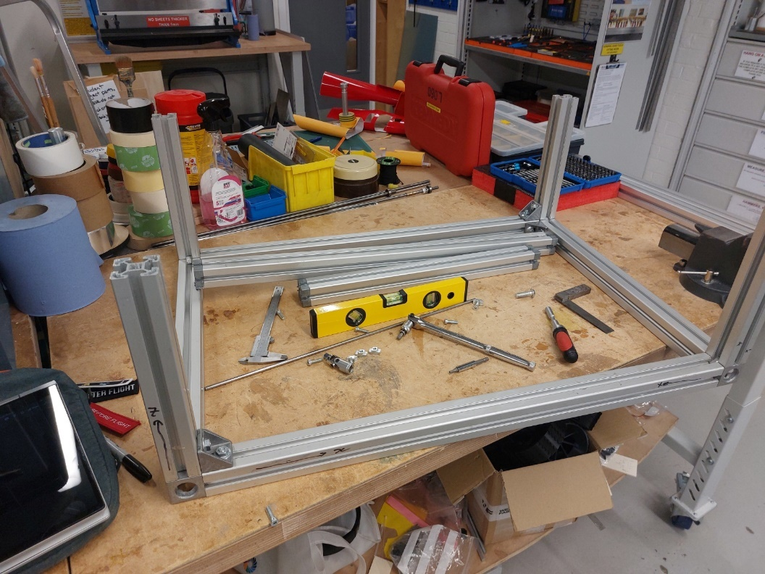

1. Once this is achieved, use the M5 bolts and wing nuts to secure a top extrusion   
   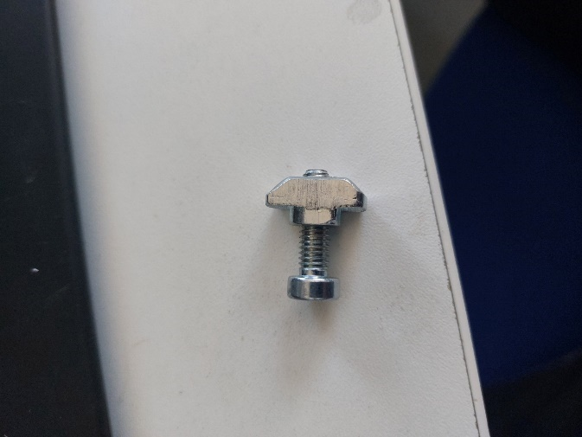
2. Level the extrusion by using a soft-head hammer to tap the bar to level.   
   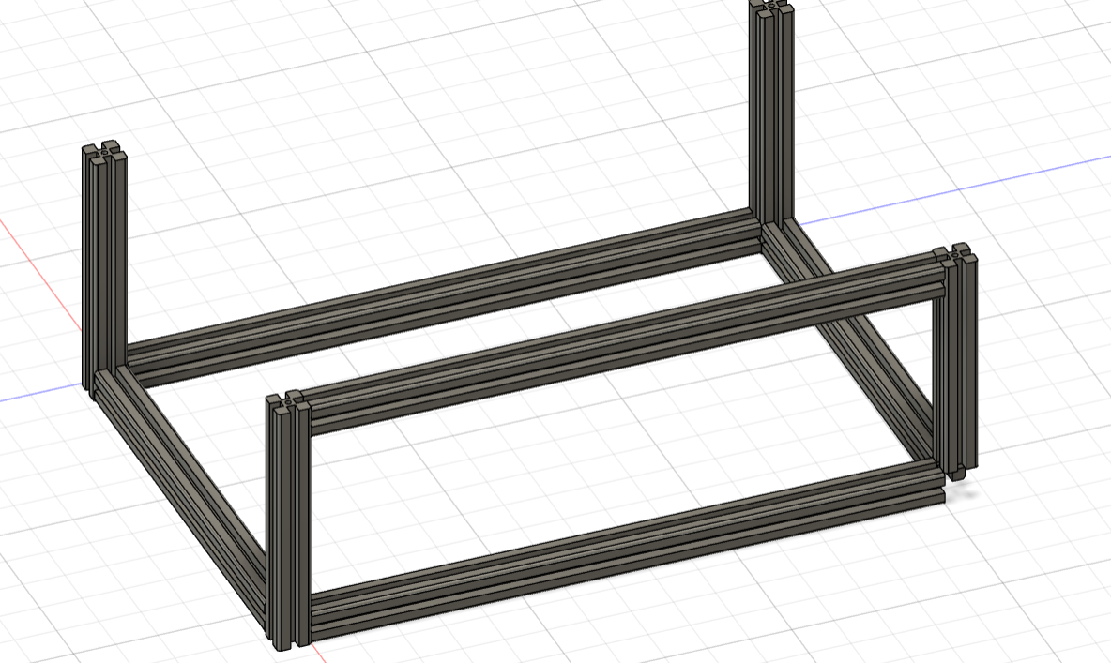
3. Do the same to a perpendicular top extrusion and measure the level as shown below. Start with measurement 1 (blue) then continue to measurement 2 (red).   
   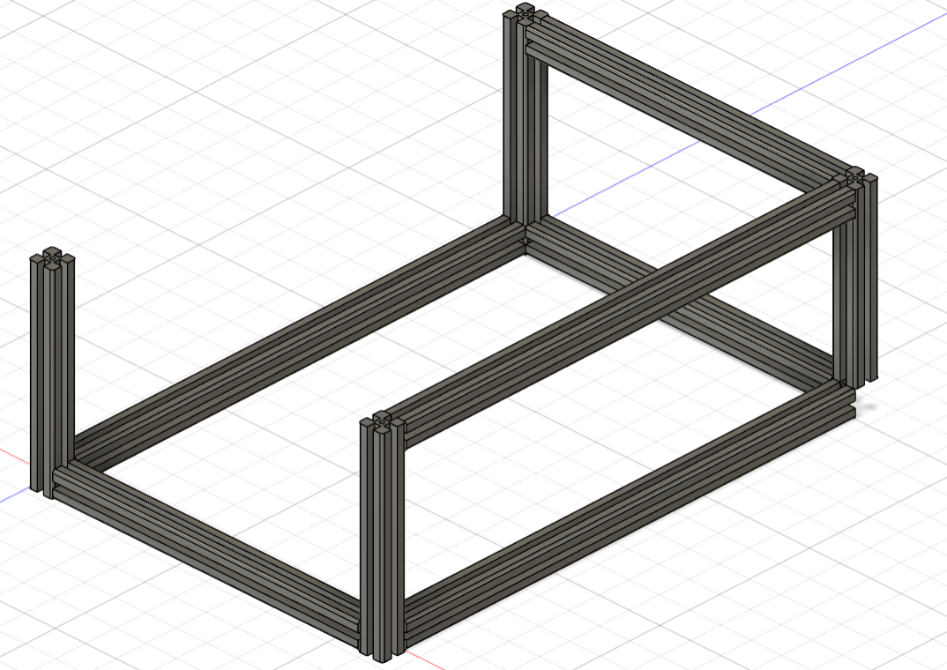
4. Repeat for steps 13-14 for all remaining bars. Until all bars are assembled and level.
5. Attach all corner holders using M6 nuts and bolts
6. Assemble rail holders. To do this place one side of the rail holder down, place the $0.8mm$ linear bearing in the allocated space.
7. Place the belt holder and the filed bolt in its allocated place 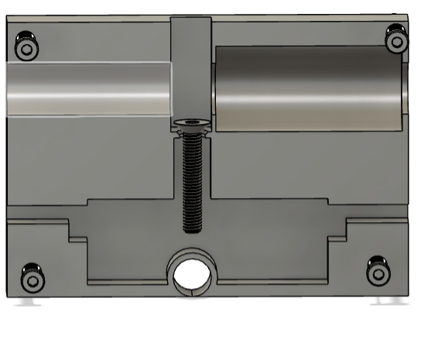

Belt holder / bolt

Linear bearing

Linear bearing

1. Slightly fasten the belt putting pressure on the belt holder belt so that it stays in line with the assembly.
2. Screw the 4 fastening bolts.
3. Tighten the belt holder bolt by accessing it via the hole in the top of the assembly.
4. Repeat for all other belt holders.
5. Place metal bars in corresponding locations.
6. Slide rail holders onto metal bars.
7. Bars with tapered ends need to be placed on a side that doesn’t end in a motor.
8. With the rail holders placed on the bars, place a belt end, and bearing and then screw the tapered end if needed on the end of one side of each rod.
9. Align belts with corresponding belt ends.
10. Bearings fit into bearing holders via compression fit, they should slide in with enough force. Once all bearing holders are attached and the motor to pipe ends are fitted on the motor side, screw in the bearing holders. Left should be the motor holders.
11. To assemble the motor holders remove the back plate from the motor.
12. Use the M3x40 screws and place the back plate on the inside of the motor holder.
13. Align both the wires and the rest of the so that the screw goes all the way to the tapered start of the remaining section of the motor.
14. Secure the motor to the inside of the motor holder.
15. Repeat for the second holder
16. Assemble the remaining parts, so that the rig looks like the below (without the central camera holder)  
    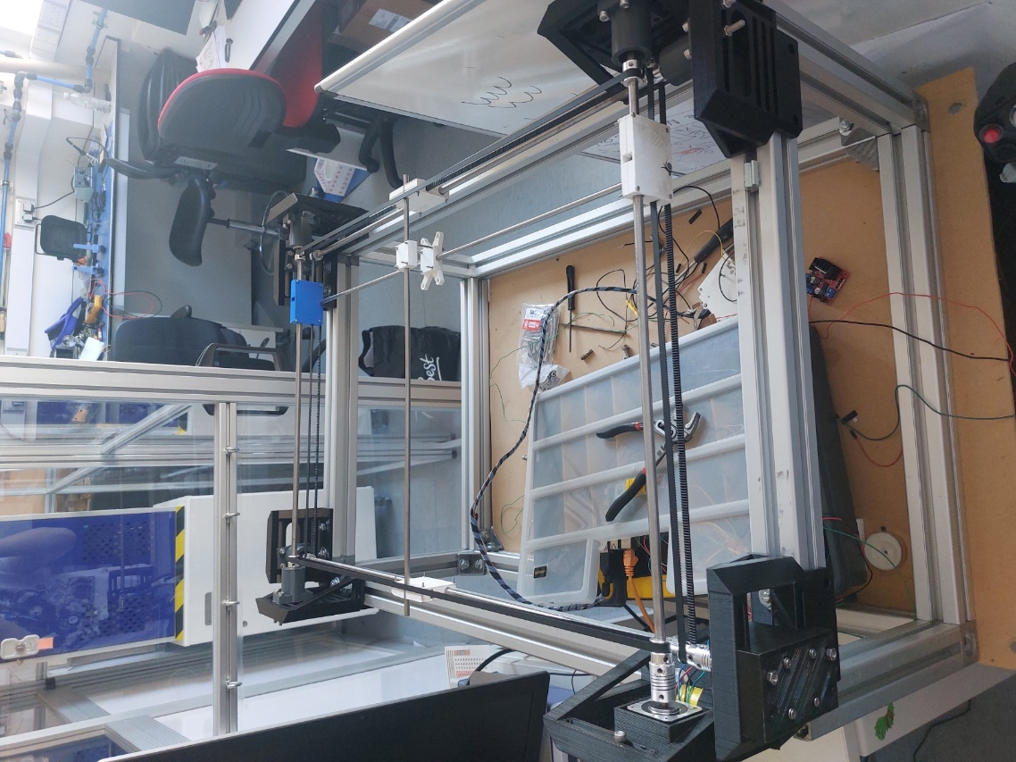
17. Tension all belts by adjusting the position of the bearing holders and the motor holders on the rig.
18. Assemble the camera holder by attaching all screws to the cameras.
19. Place 0.6mm linear bearing in its allocated place and assemble it like the rail holders.
20. Once the central camera holder is secured use the same bolts M5 bolts used for the corner mounts to
21. secure the PI and PCB to the main frame.
22. Attach wires as shown on the PCB.
23. Power the PI and attach camera USB, keyboard

## 4.2 Design Philosophy

The design of the rig is quite simple, the mechanical aspect is essentially two motors that either actuate the X direction or Y direction. Aligning a bar perpendicular to the motor actuation direction on both x and y and constraining the bars allows for accurate pointing to a position. To align the bars with each other, motor and bearing mounts were made. These were designed so that they sat on each corner of the rig aligning the $90°$ corners to each other. The camera is then mounted to the rods, both with constraining linear bearings that allow a smooth translation up and down the bars. These bars are of course actuated by the motors via another bar and belt system, such belts held on by another 3D-printed part containing a screw assembly that tightens the belt to the roof of the structure.

The motors are also housed in the motor housing system that allows tensioning of the belt; the same system is on all motor/ bearing holders. This means that all belts can be adjusted to allow smooth movement of the robot. This was the basis for design, to ensure that all these holders are aligned but also adjustable in one direction to be adjustable.

The software operates on a threading process that runs multiple Python programs at the same time, allowing both the joystick and Peltier modules to operate independently of the main program. The joystick program communicates with the main program by using the print statement and then communicating that with the main program. The main program only reads when a trigger or mode button state has changed, the motor control is done in the Joystick program, this has its advantages and disadvantages however if the motor function stops working it will not raise an error so this needs to be accounted for the in future use of the rig.

The Peltier control circuit uses a mixture of both analogue and digital elements, firstly the output of the PI or Arduino controls a switching circuit that uses a PNP and NPN transistor, this then drives the output of a comparator where reference voltages that can be set using the potentiometers. The output of such comparators is then fed into a digital logic setup which powers the H-Bridge driver for the $5V$ line that drives the Peltiers themselves.

## 4.4 Print files and drawings

All print files are located in folder x in the teams, else here are drawings detailing all dimensions of printed files.

Camera Holder:

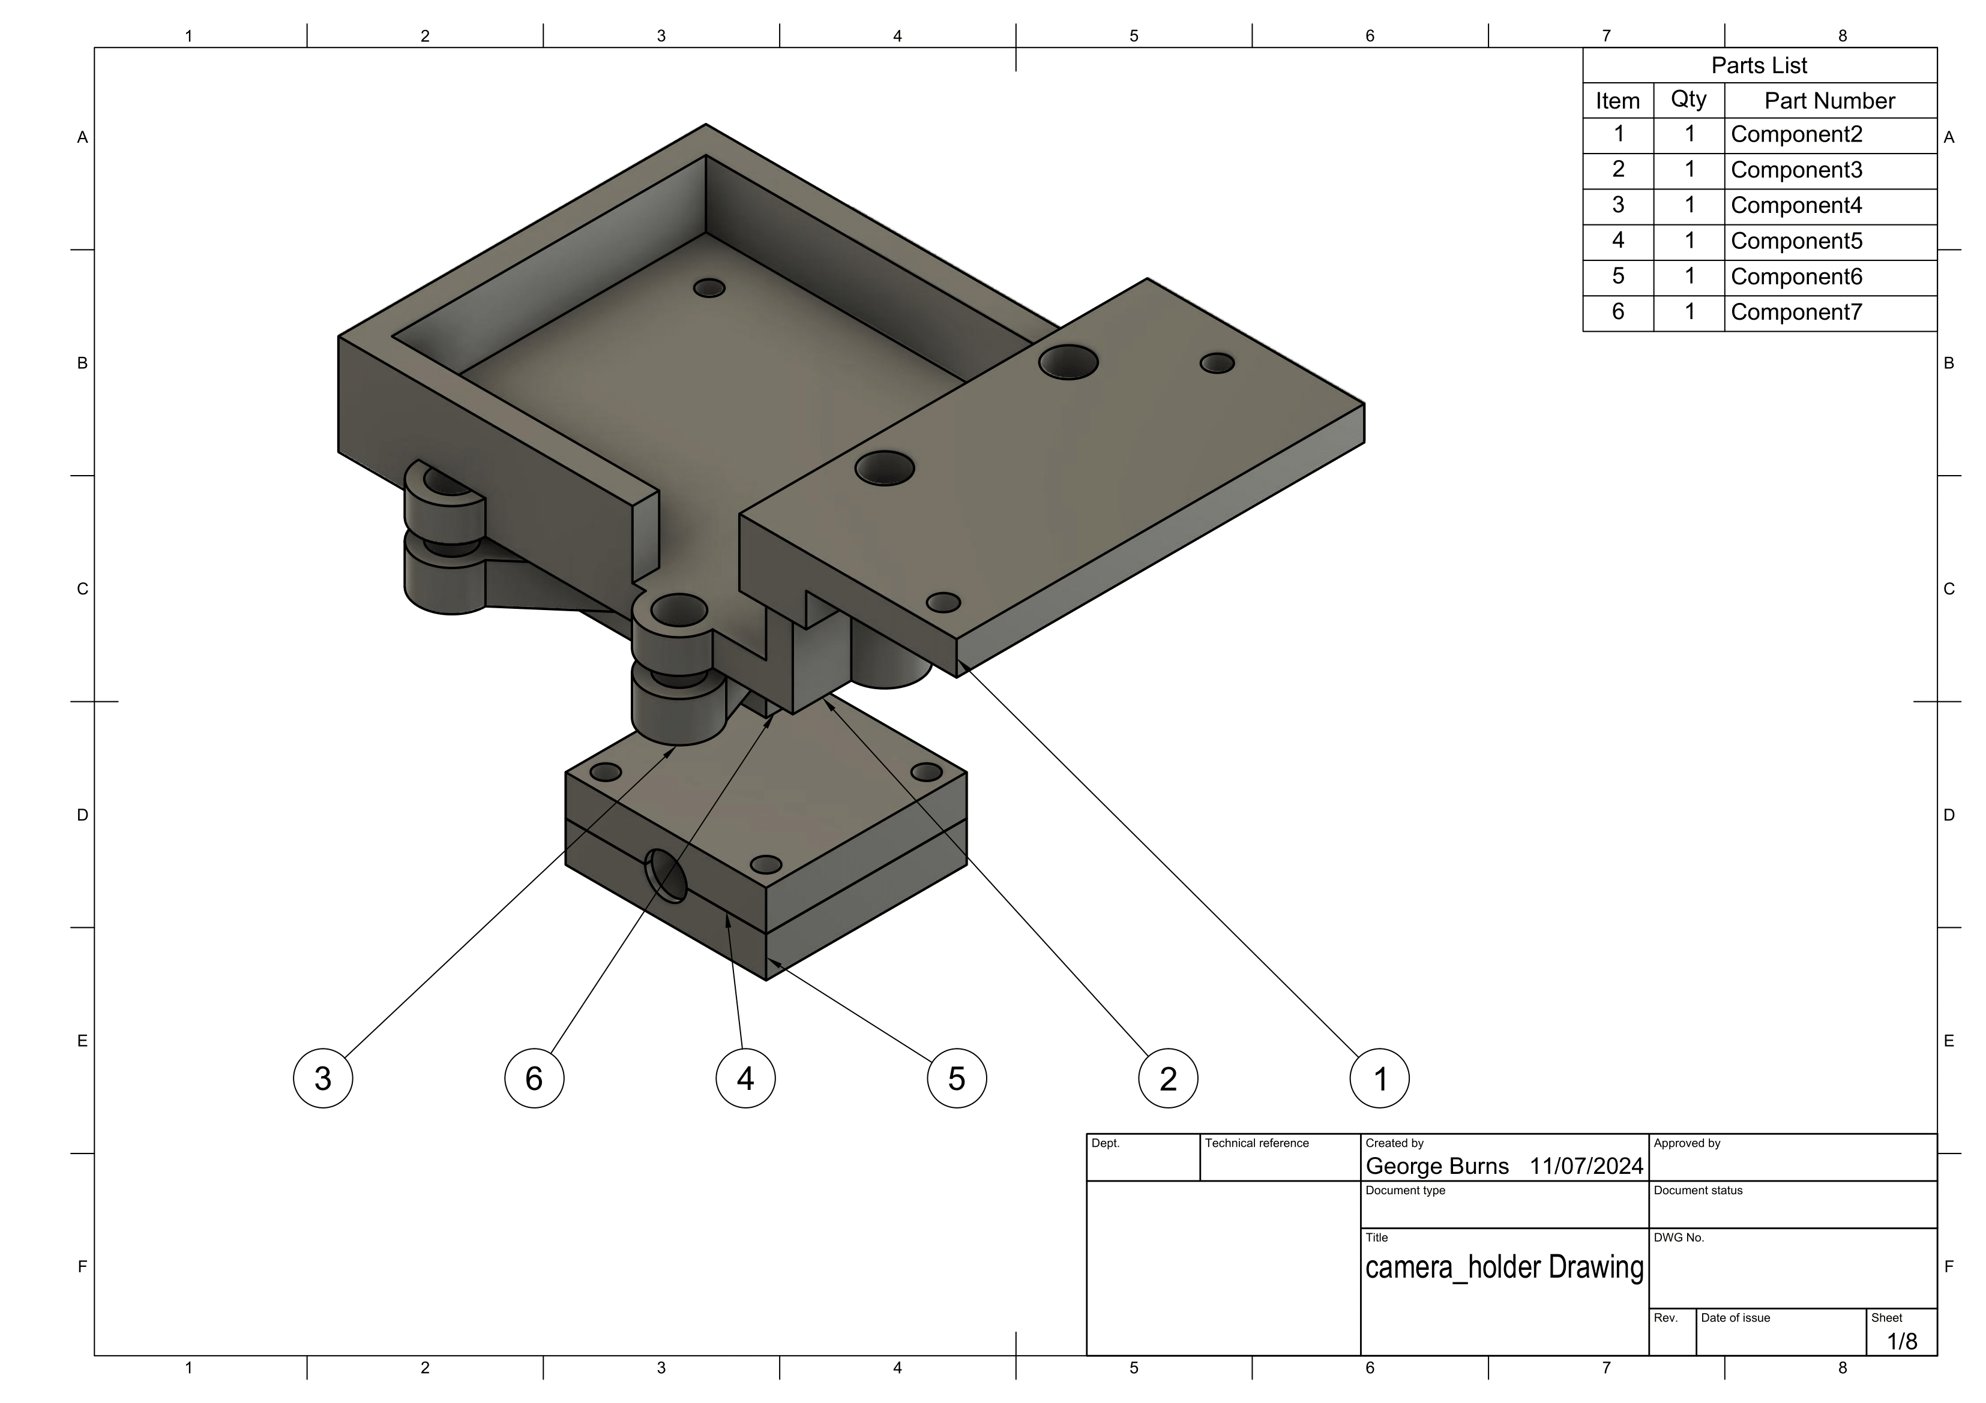

## 

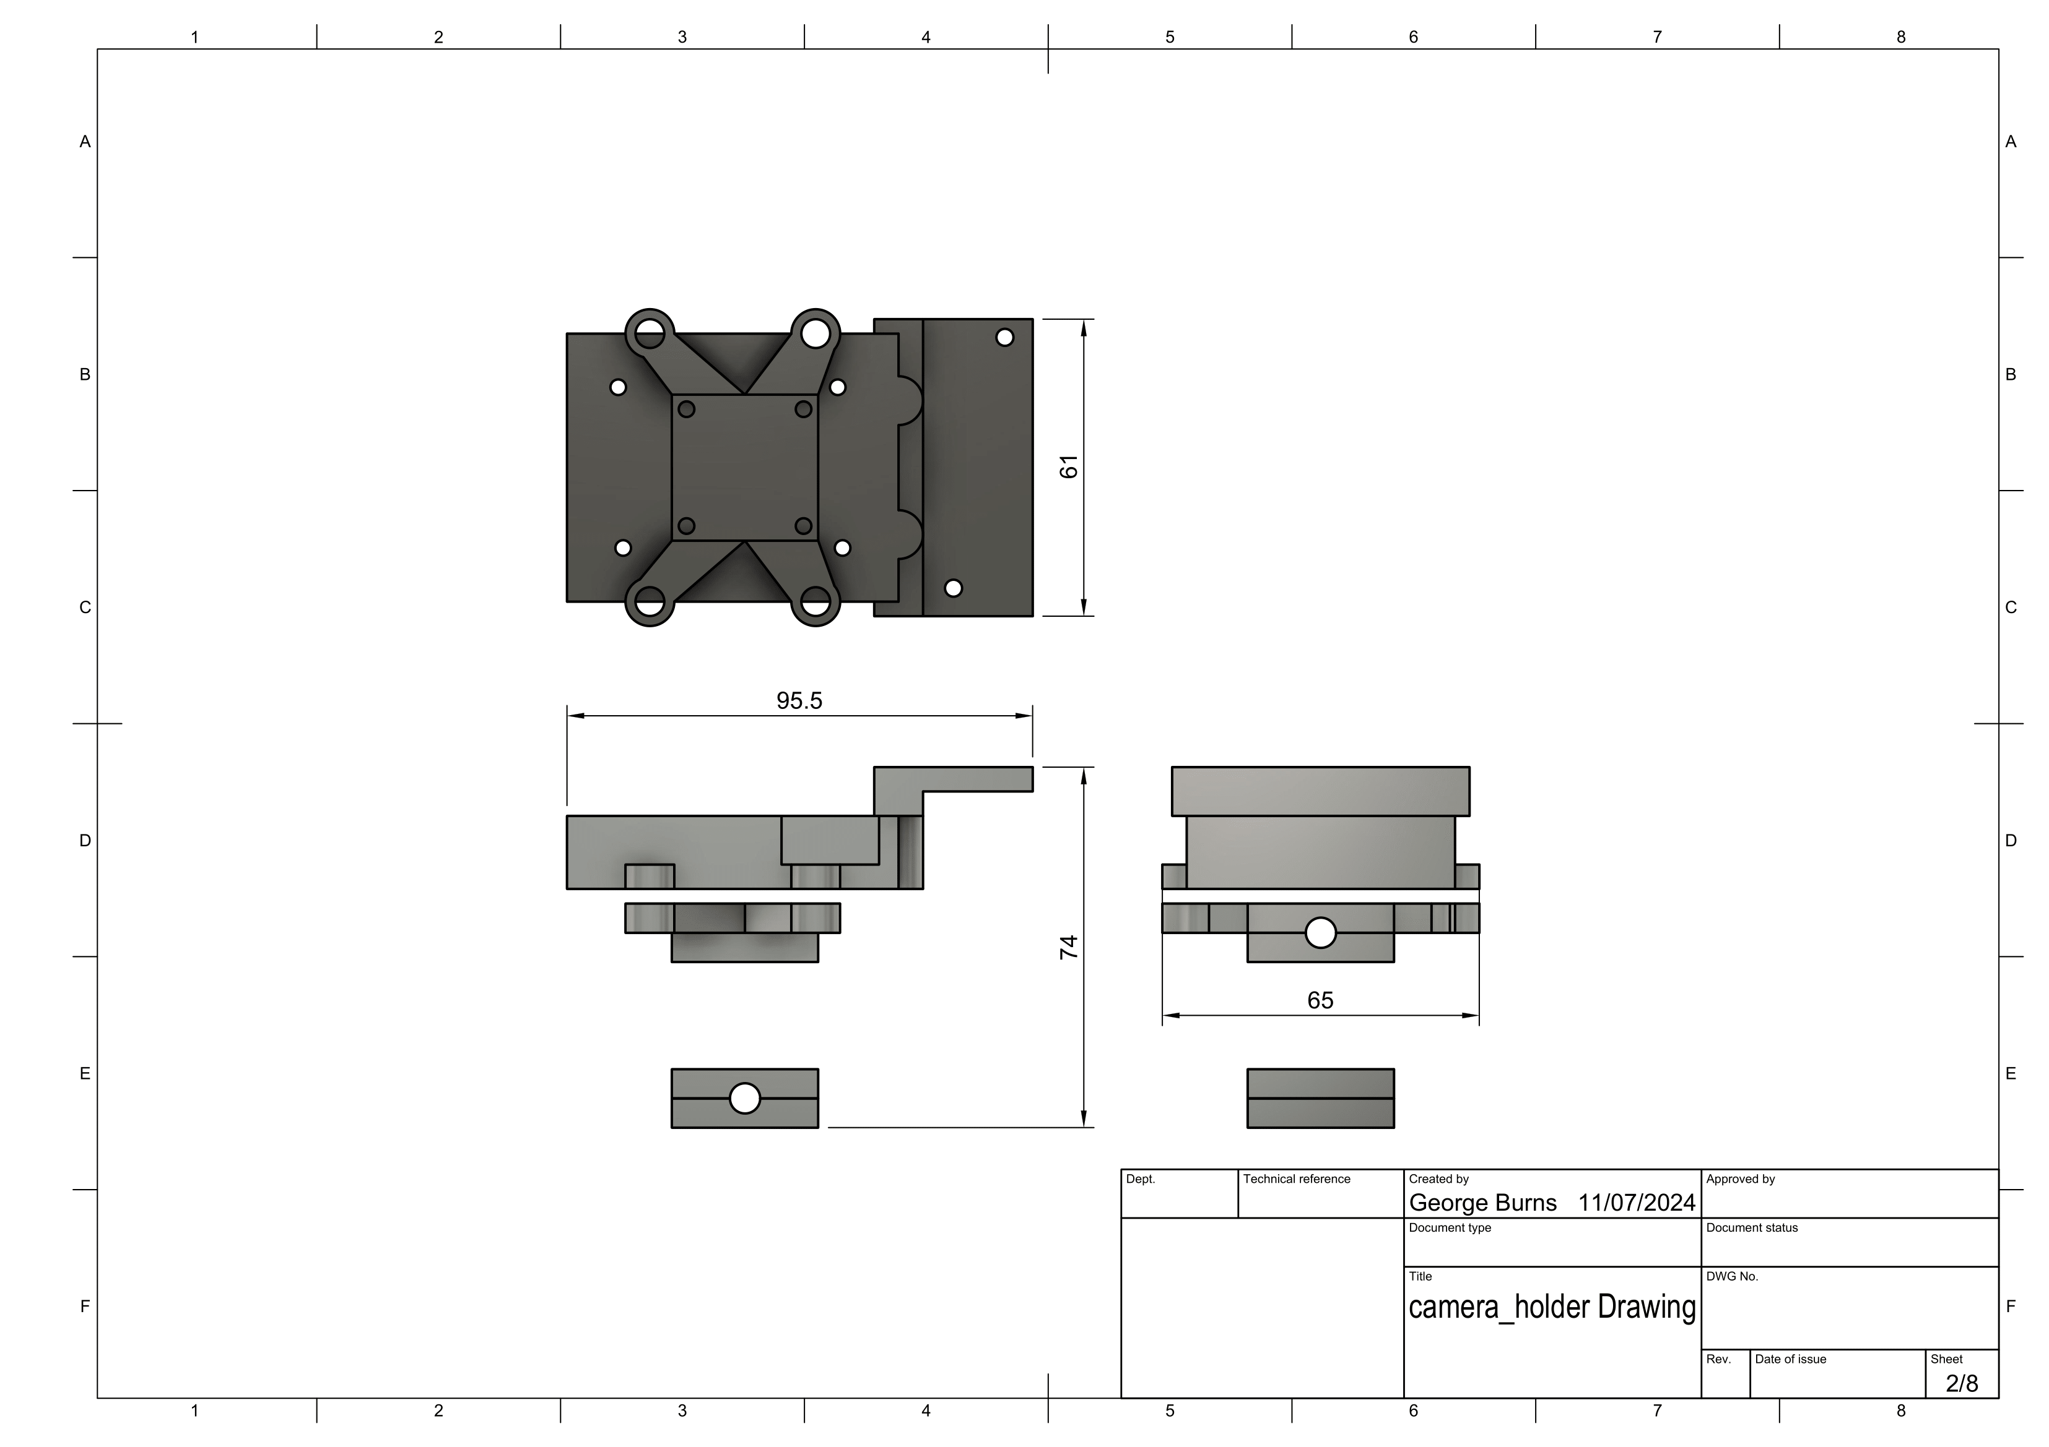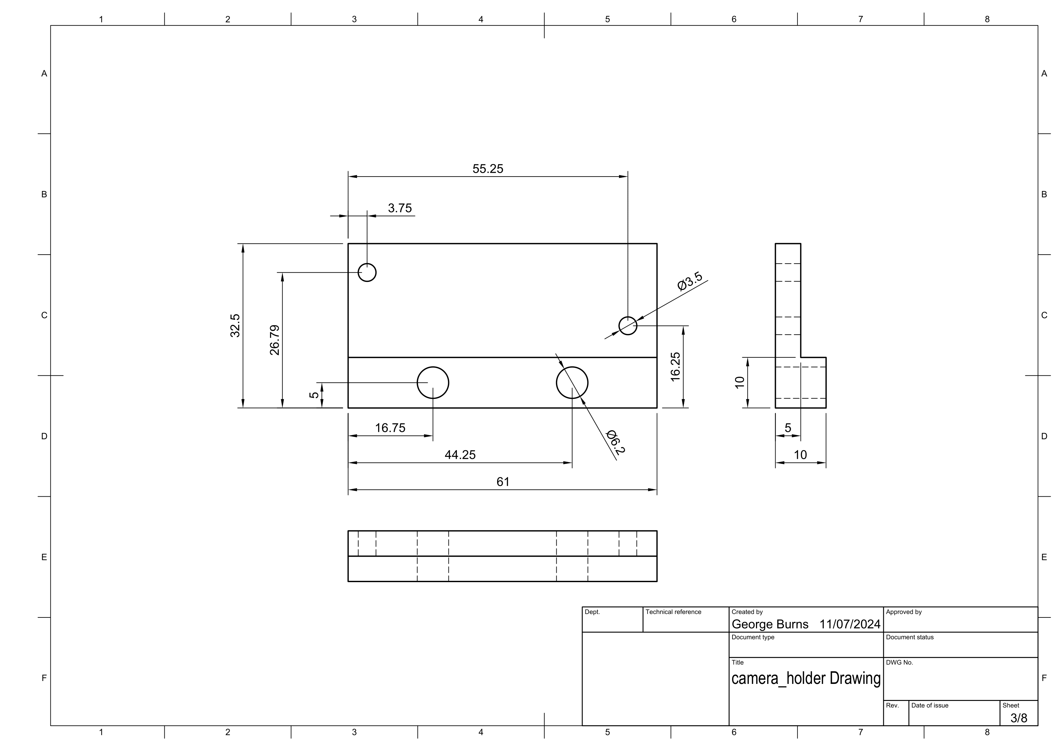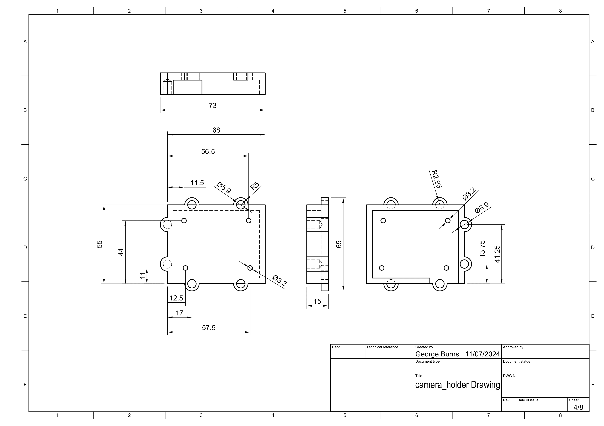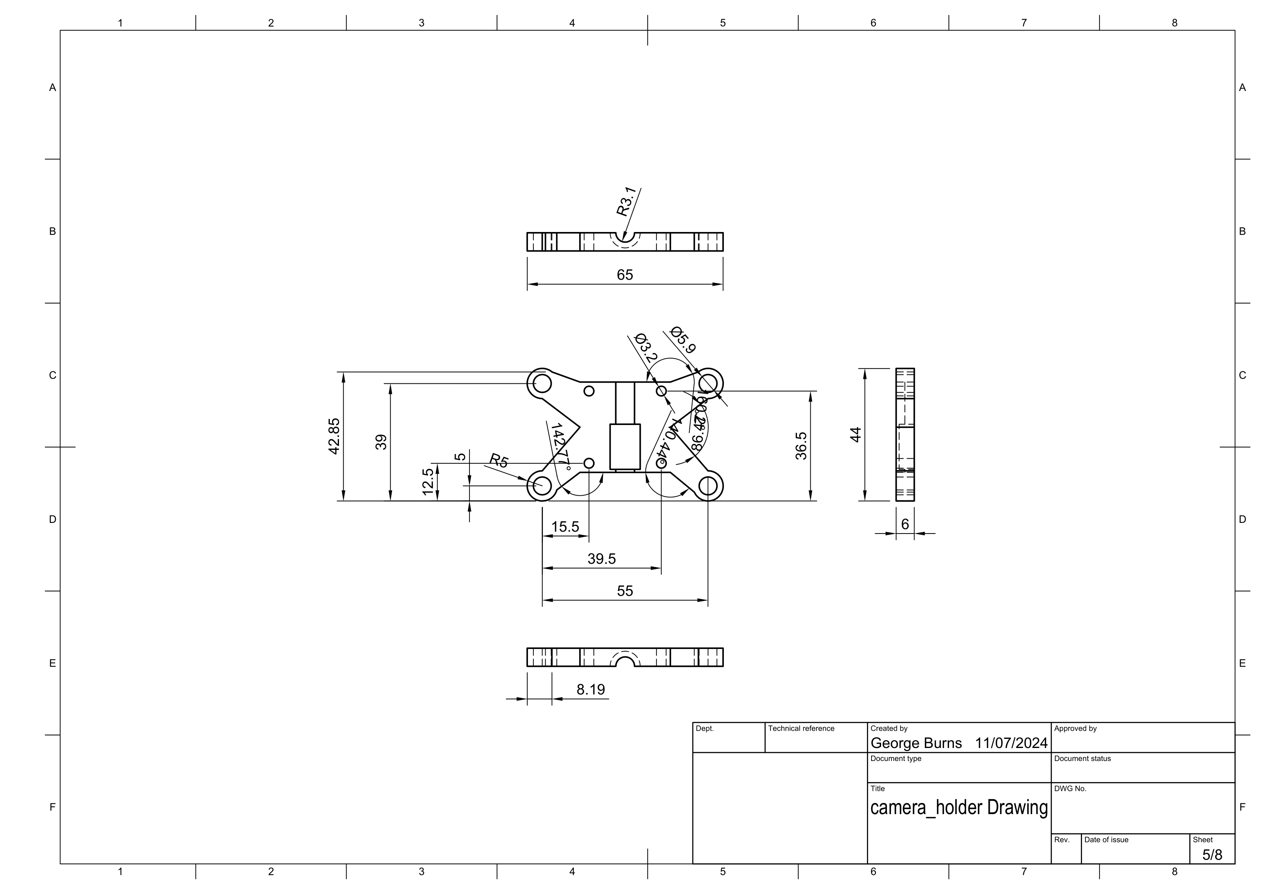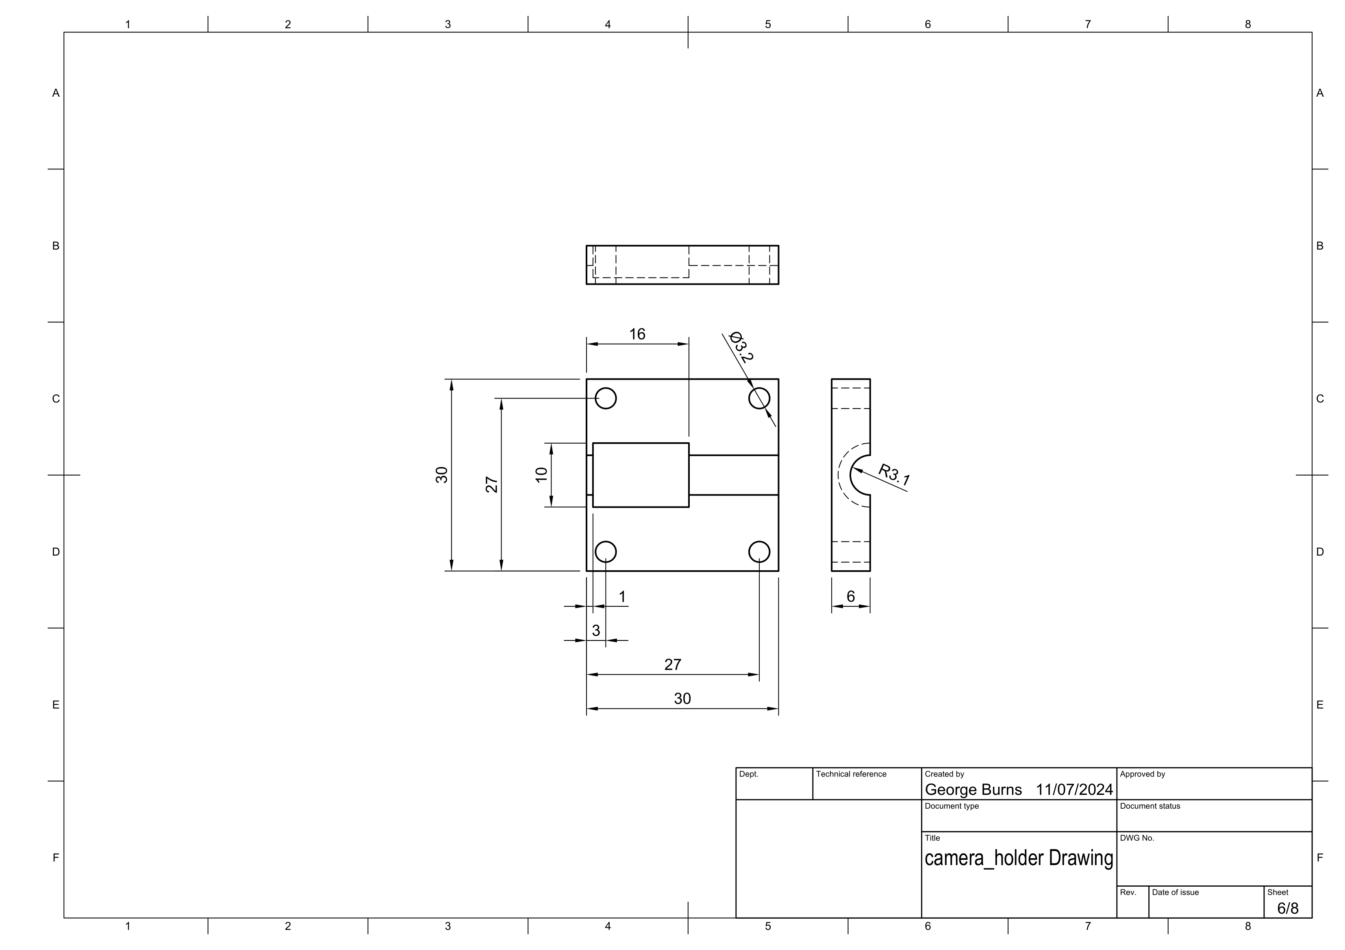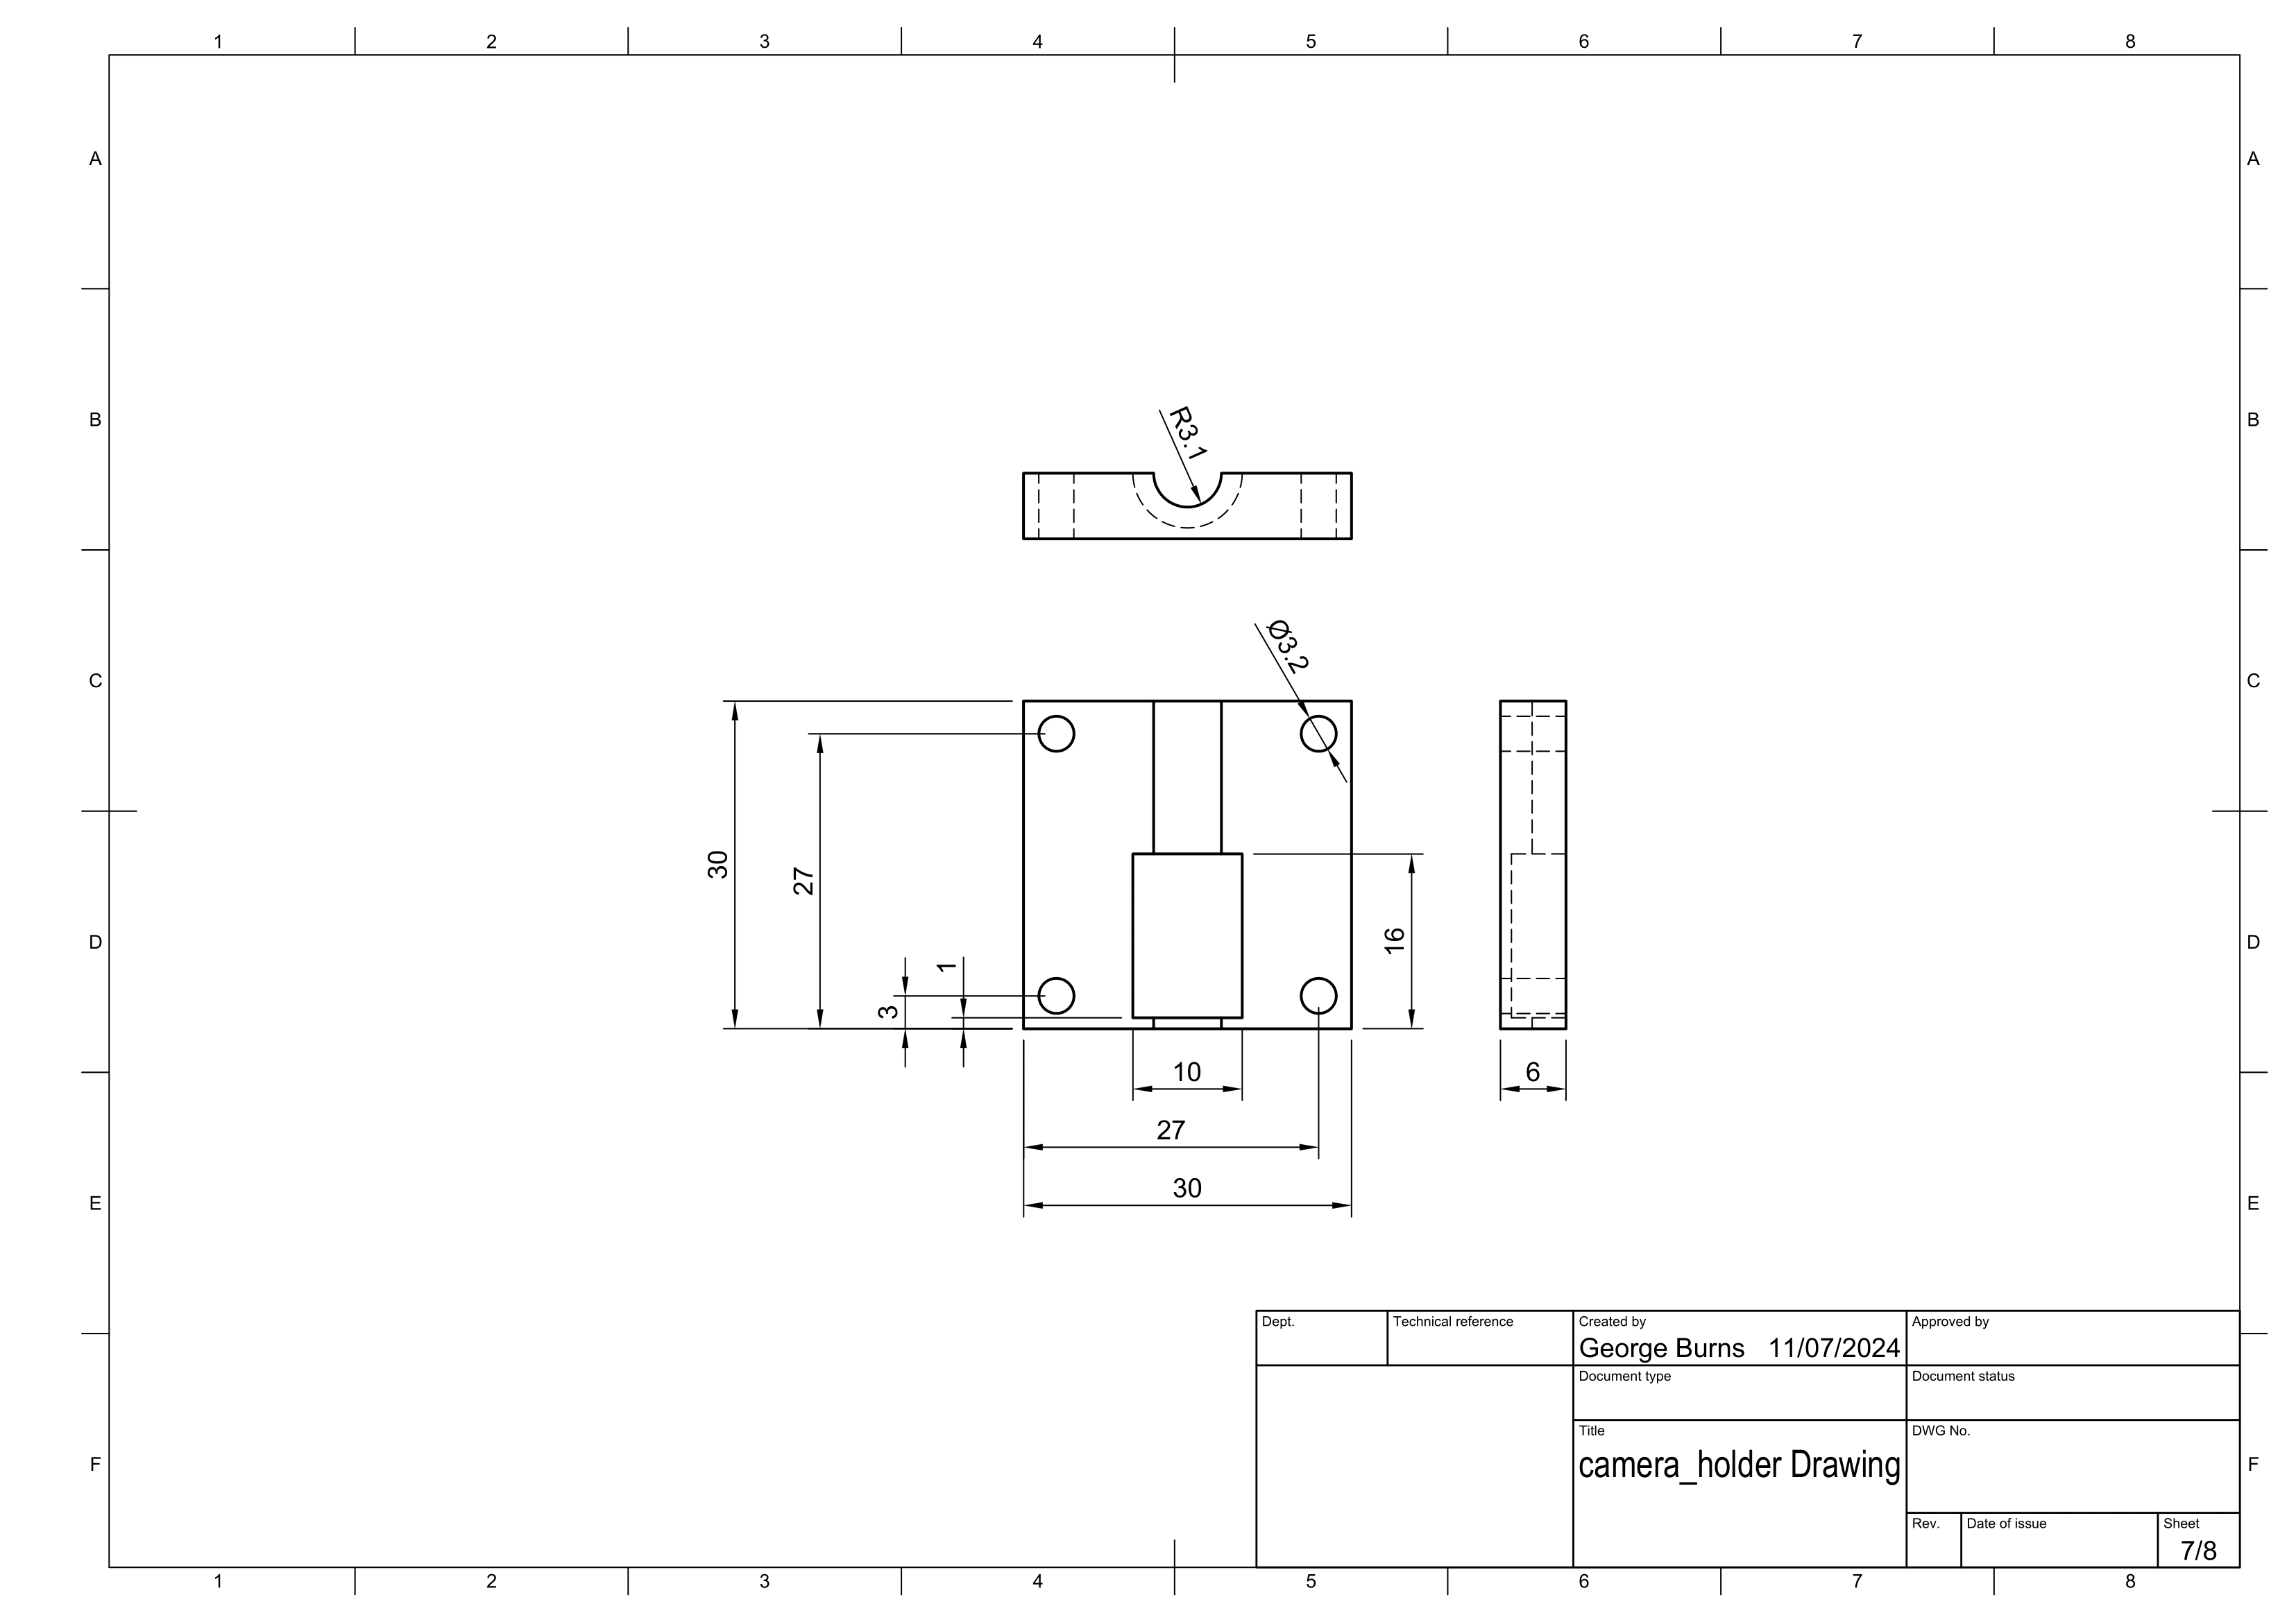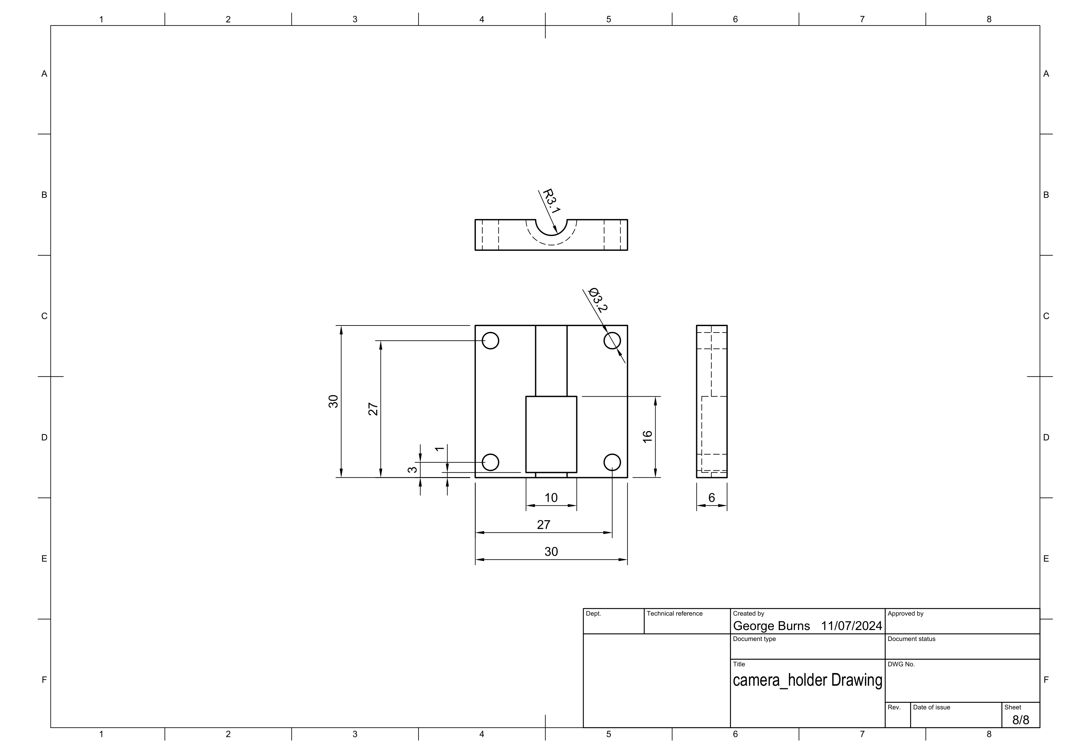

Holder_Bottom_Left:  
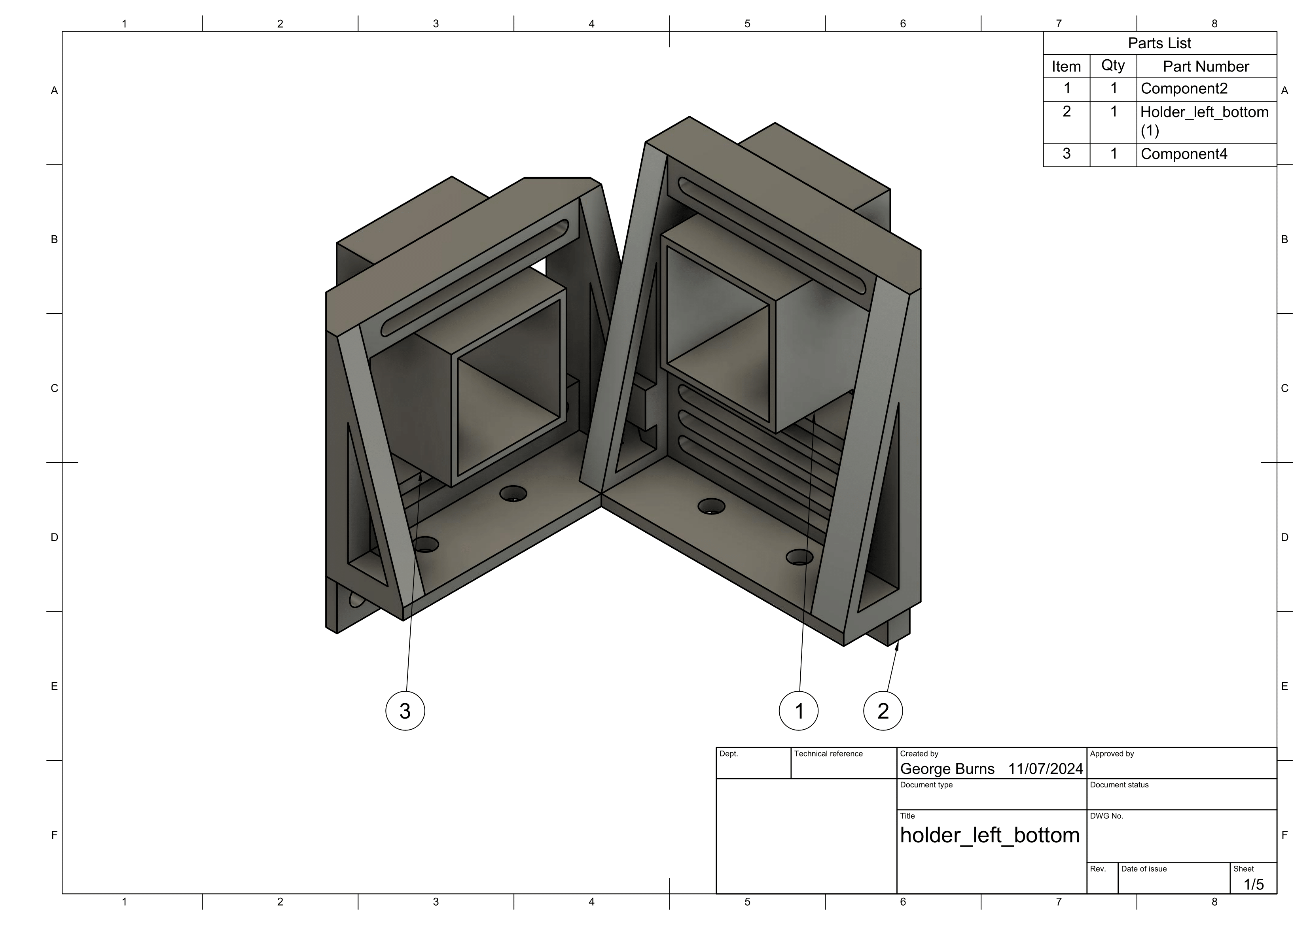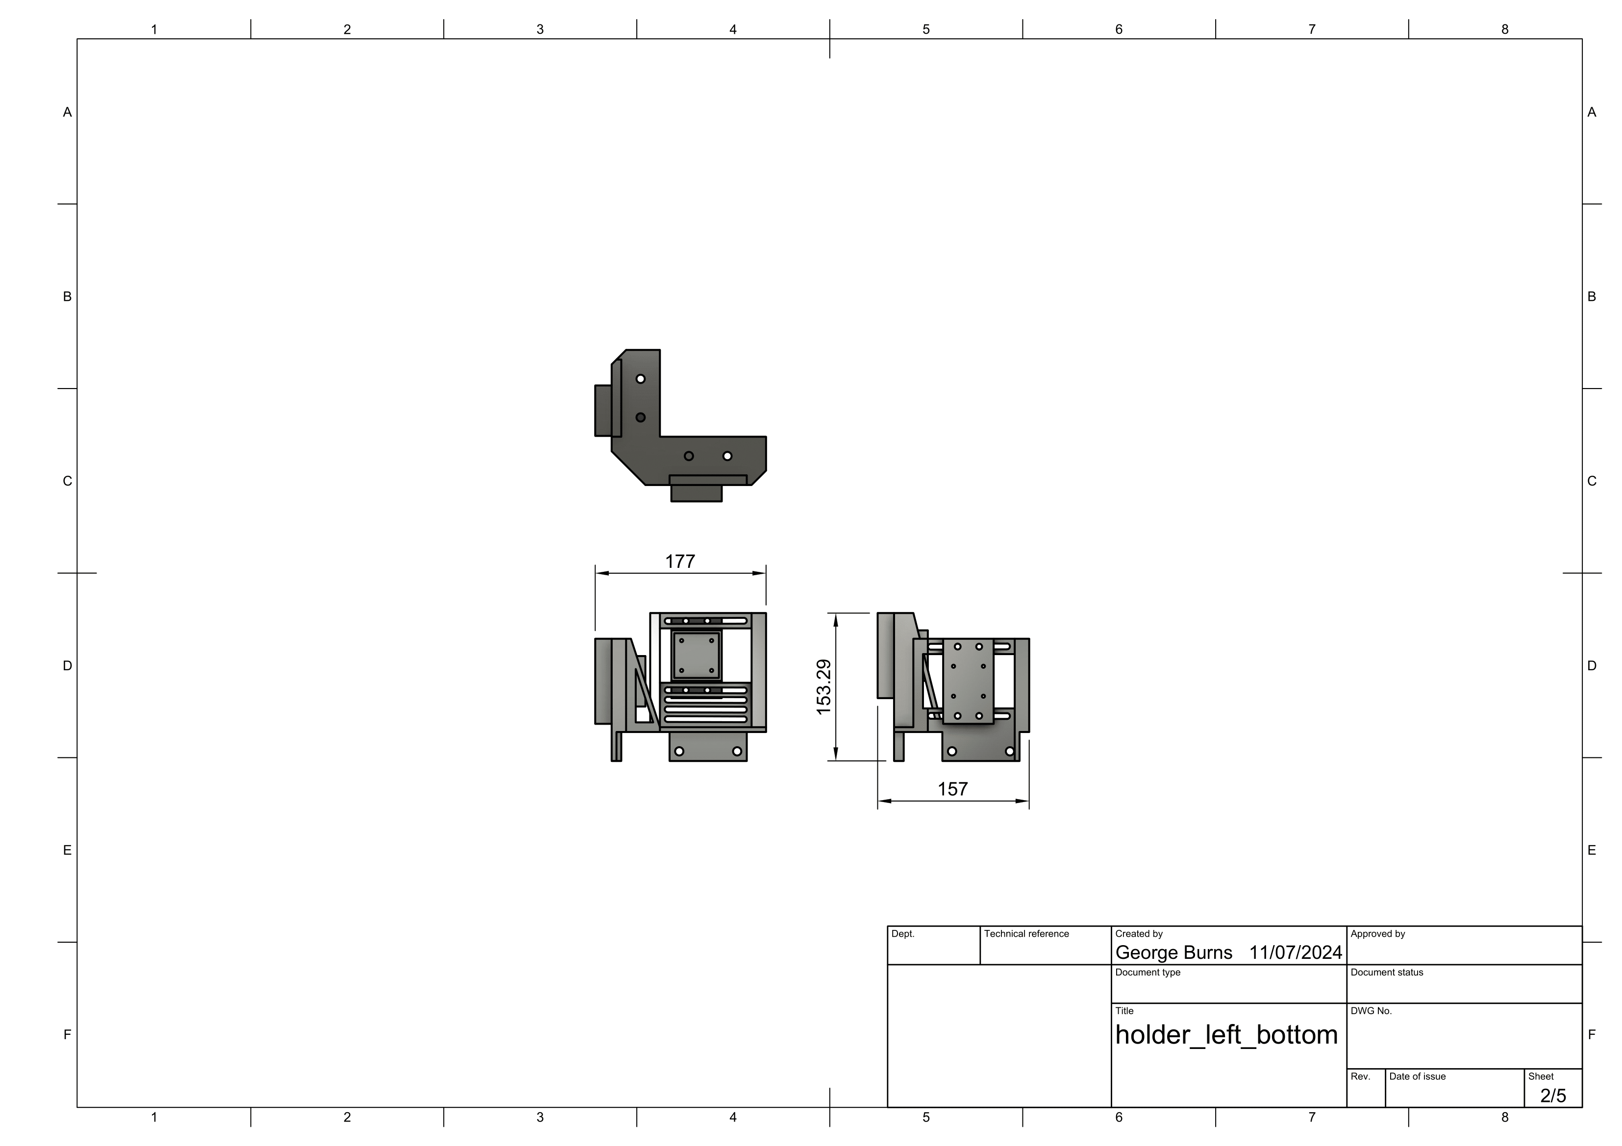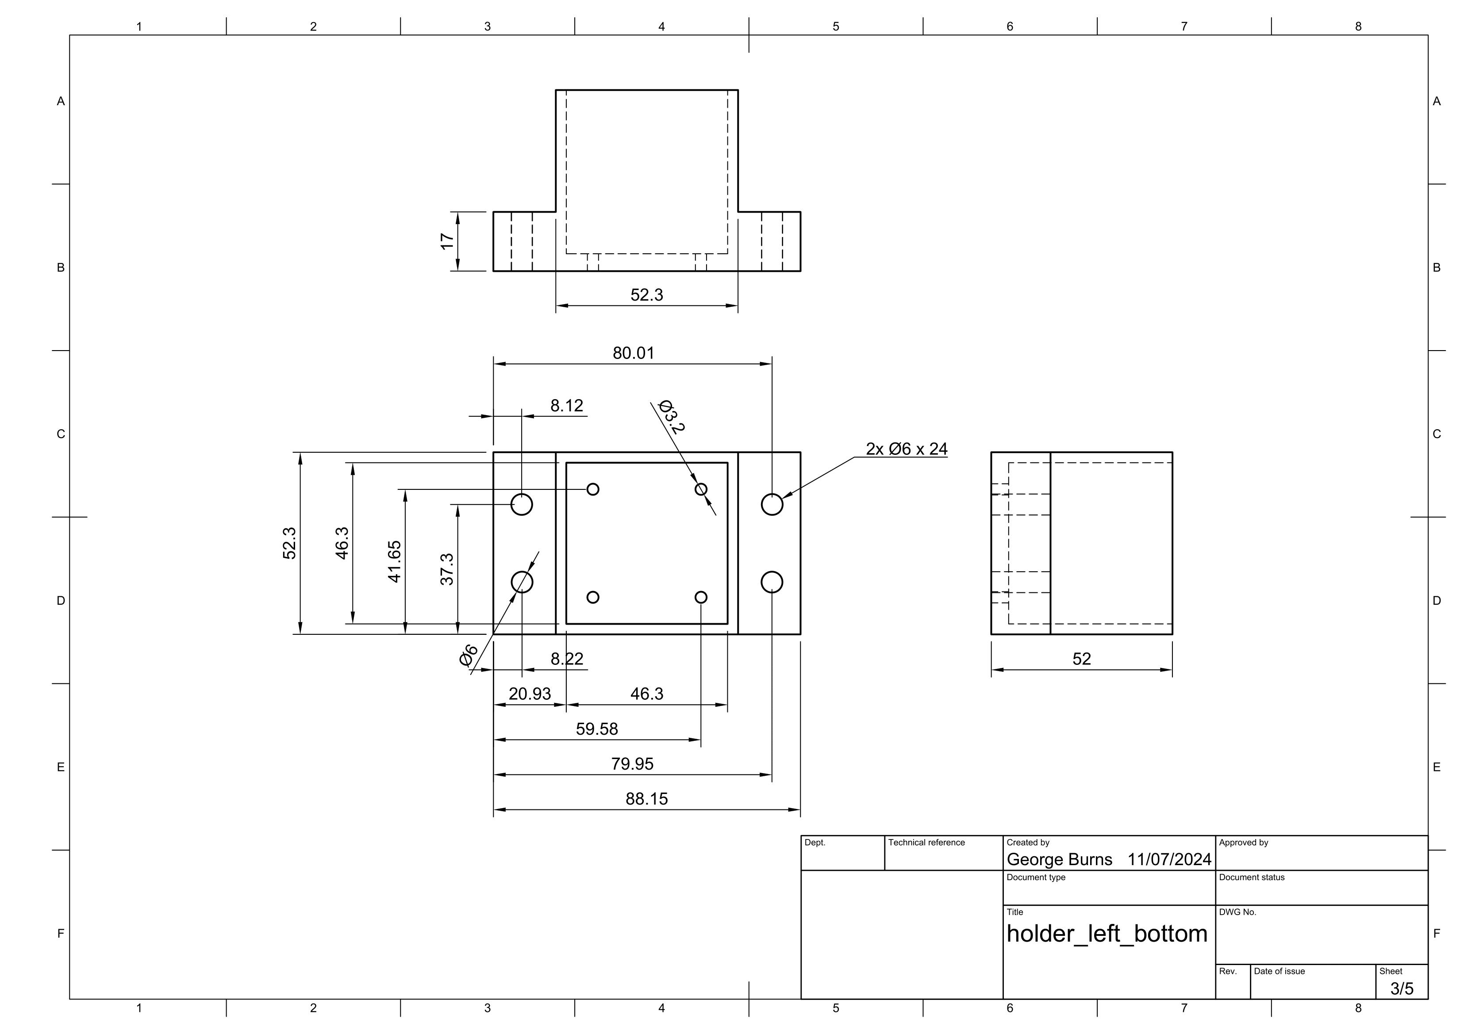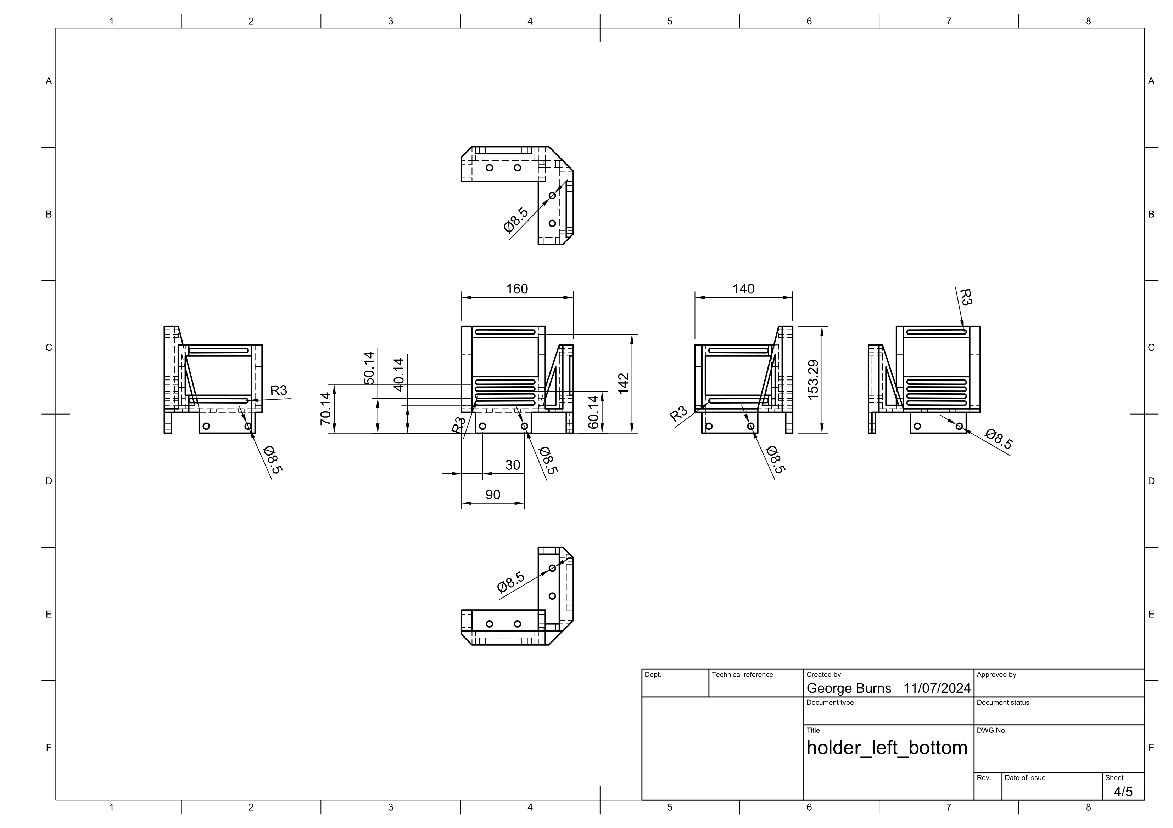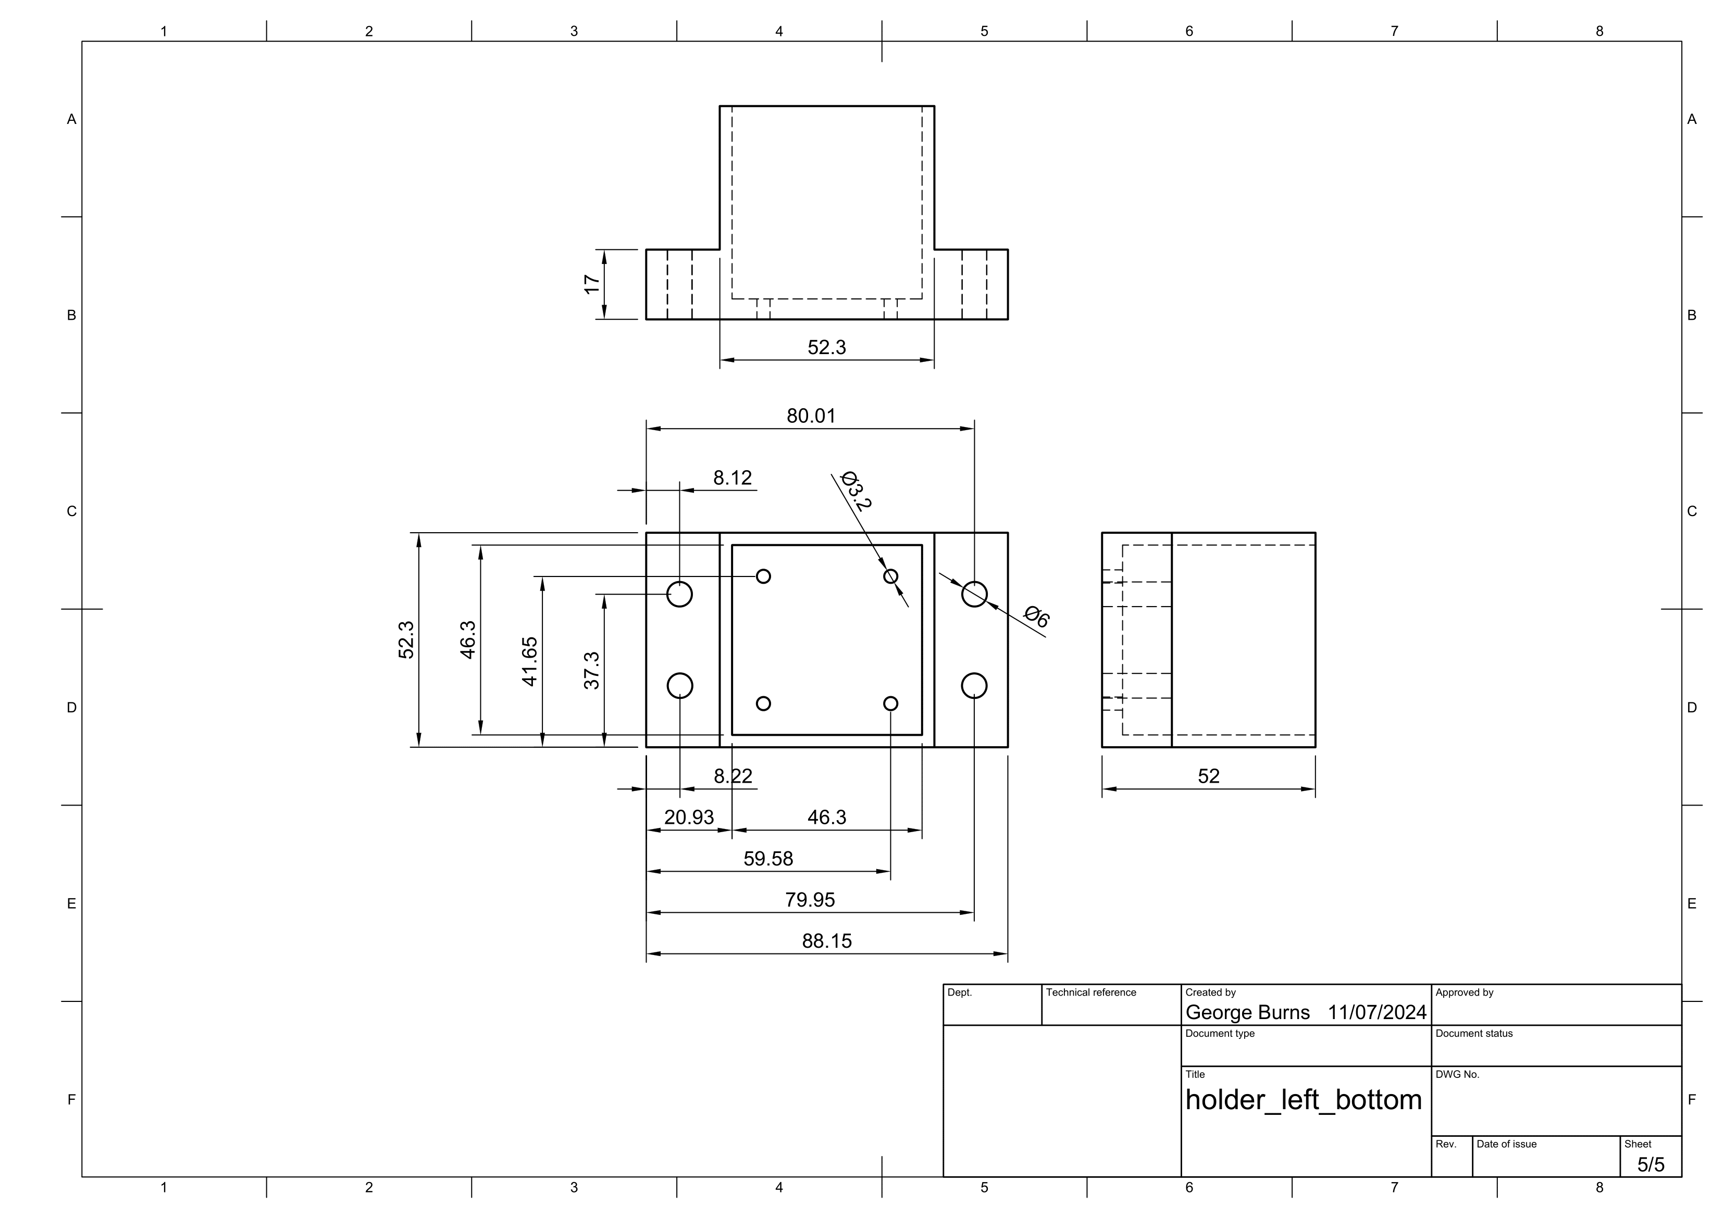

Holder top left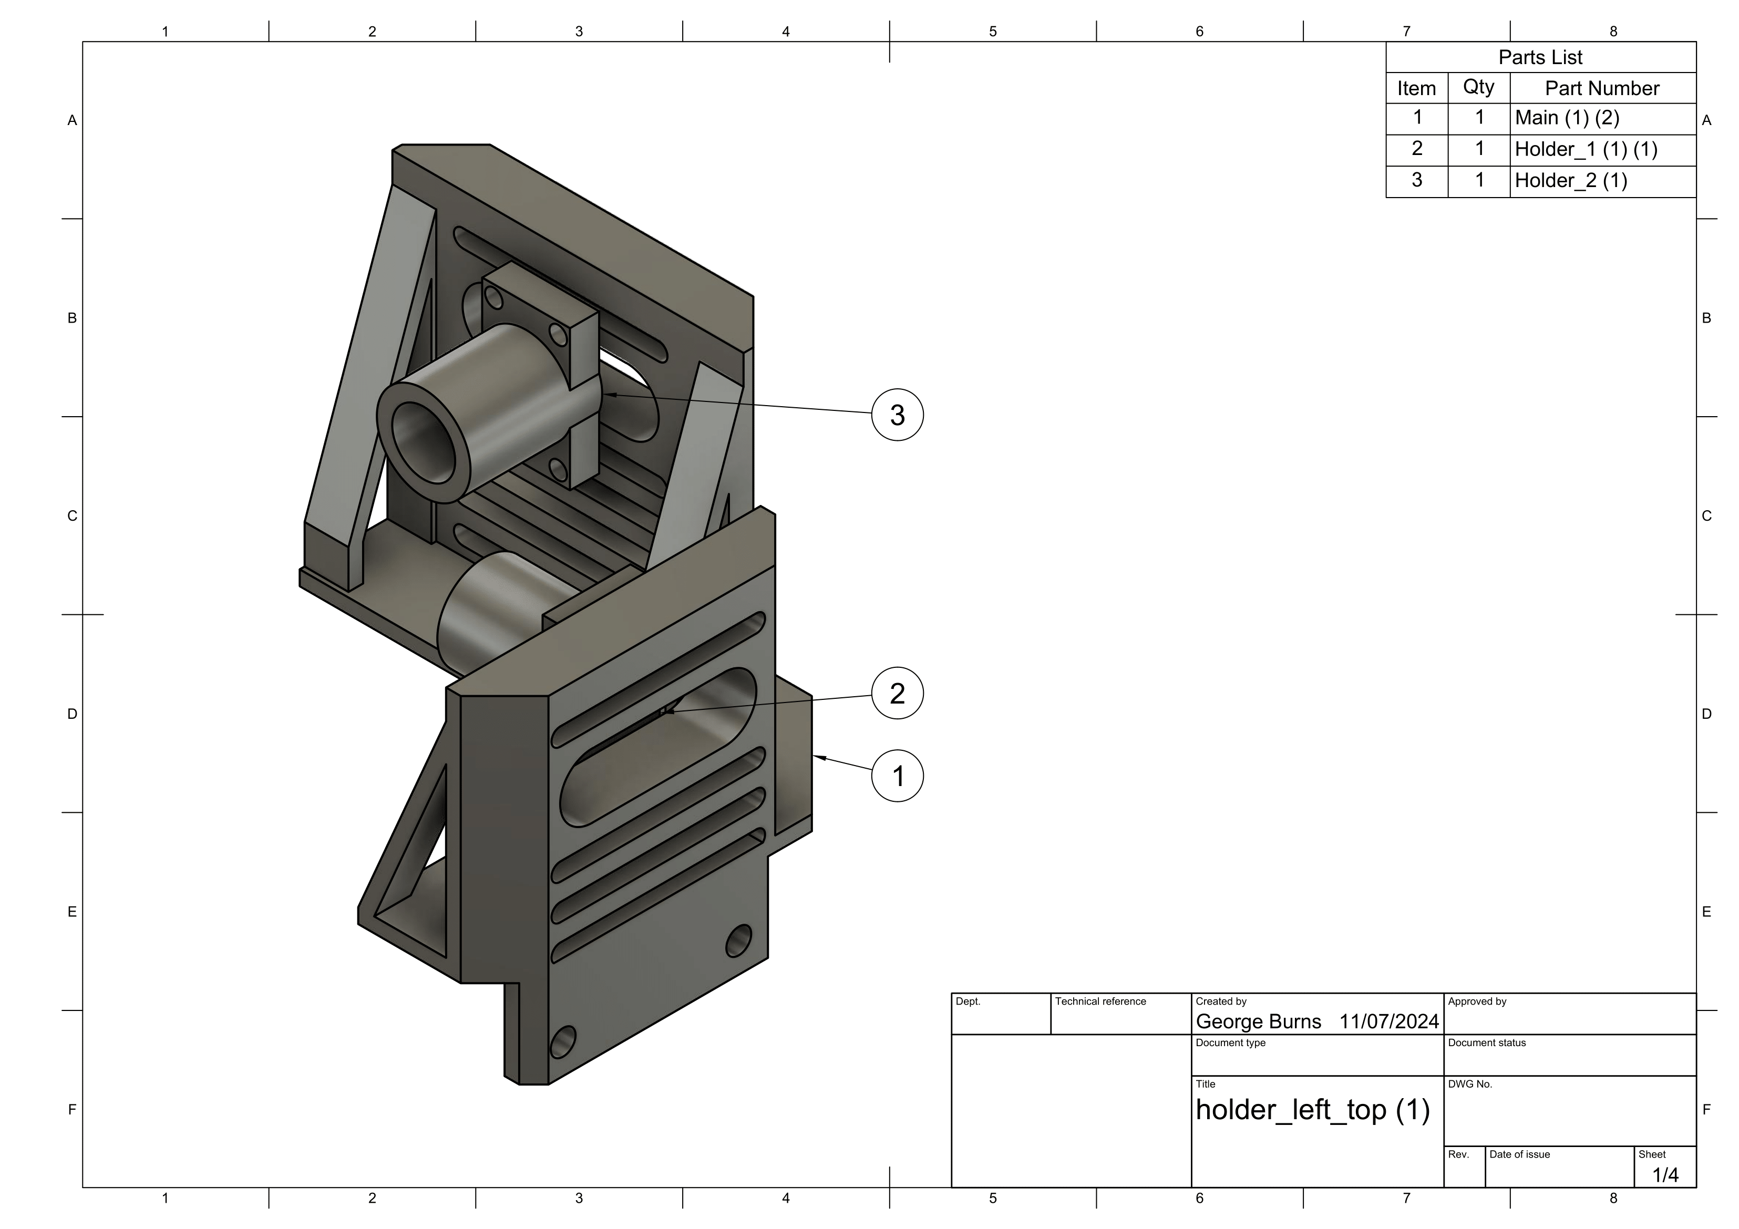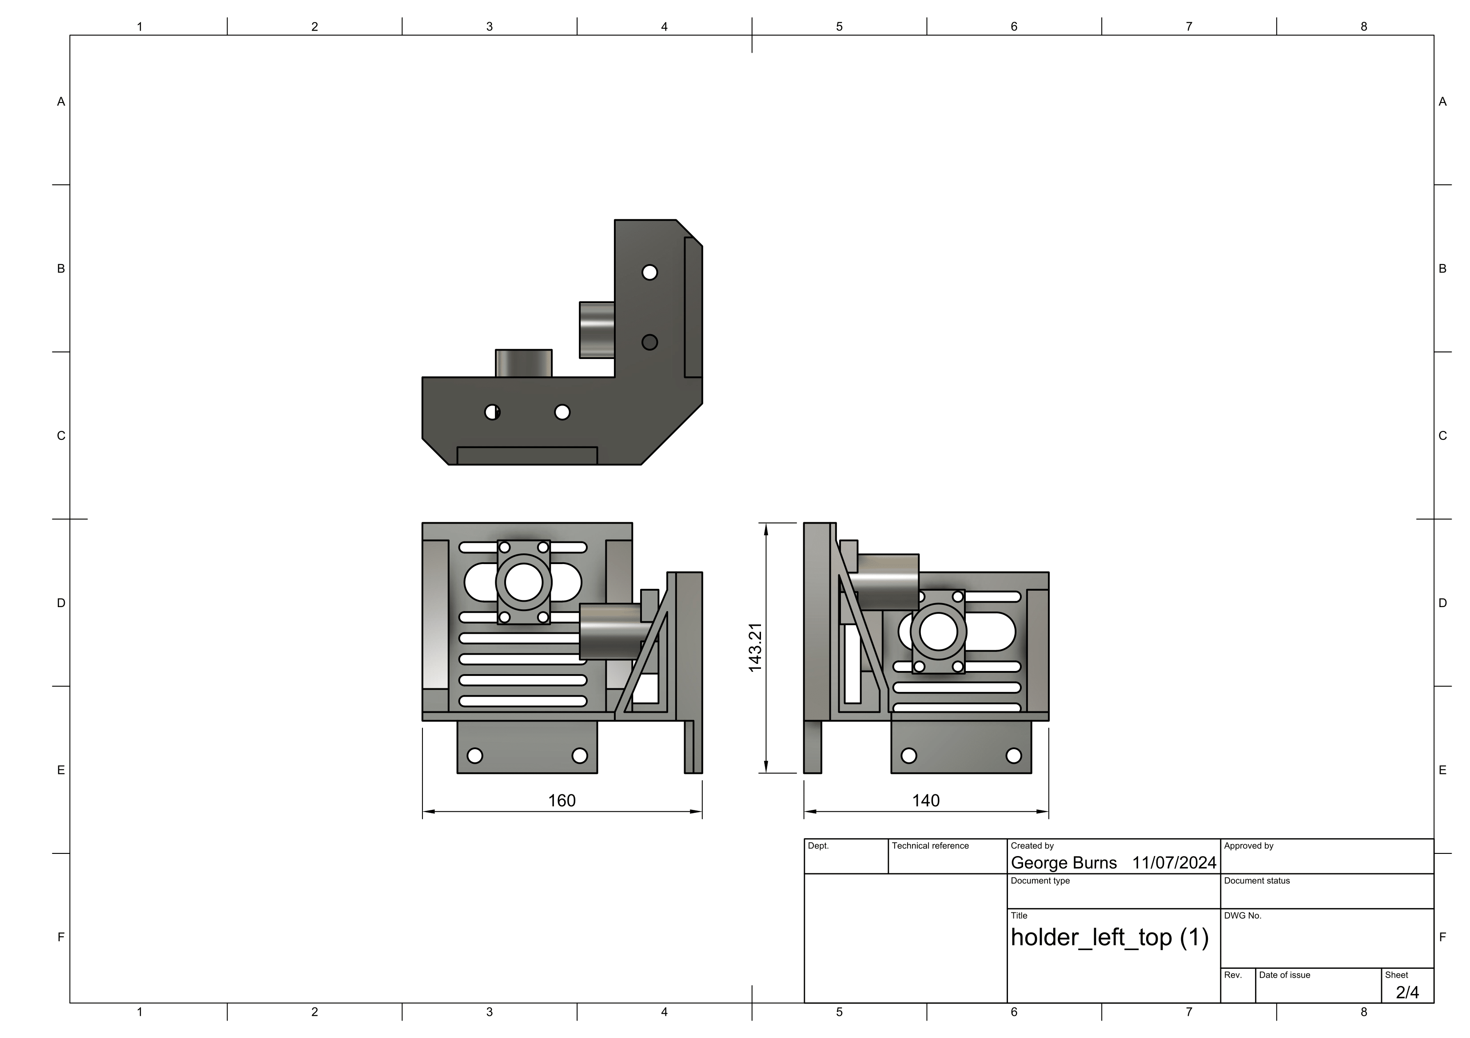

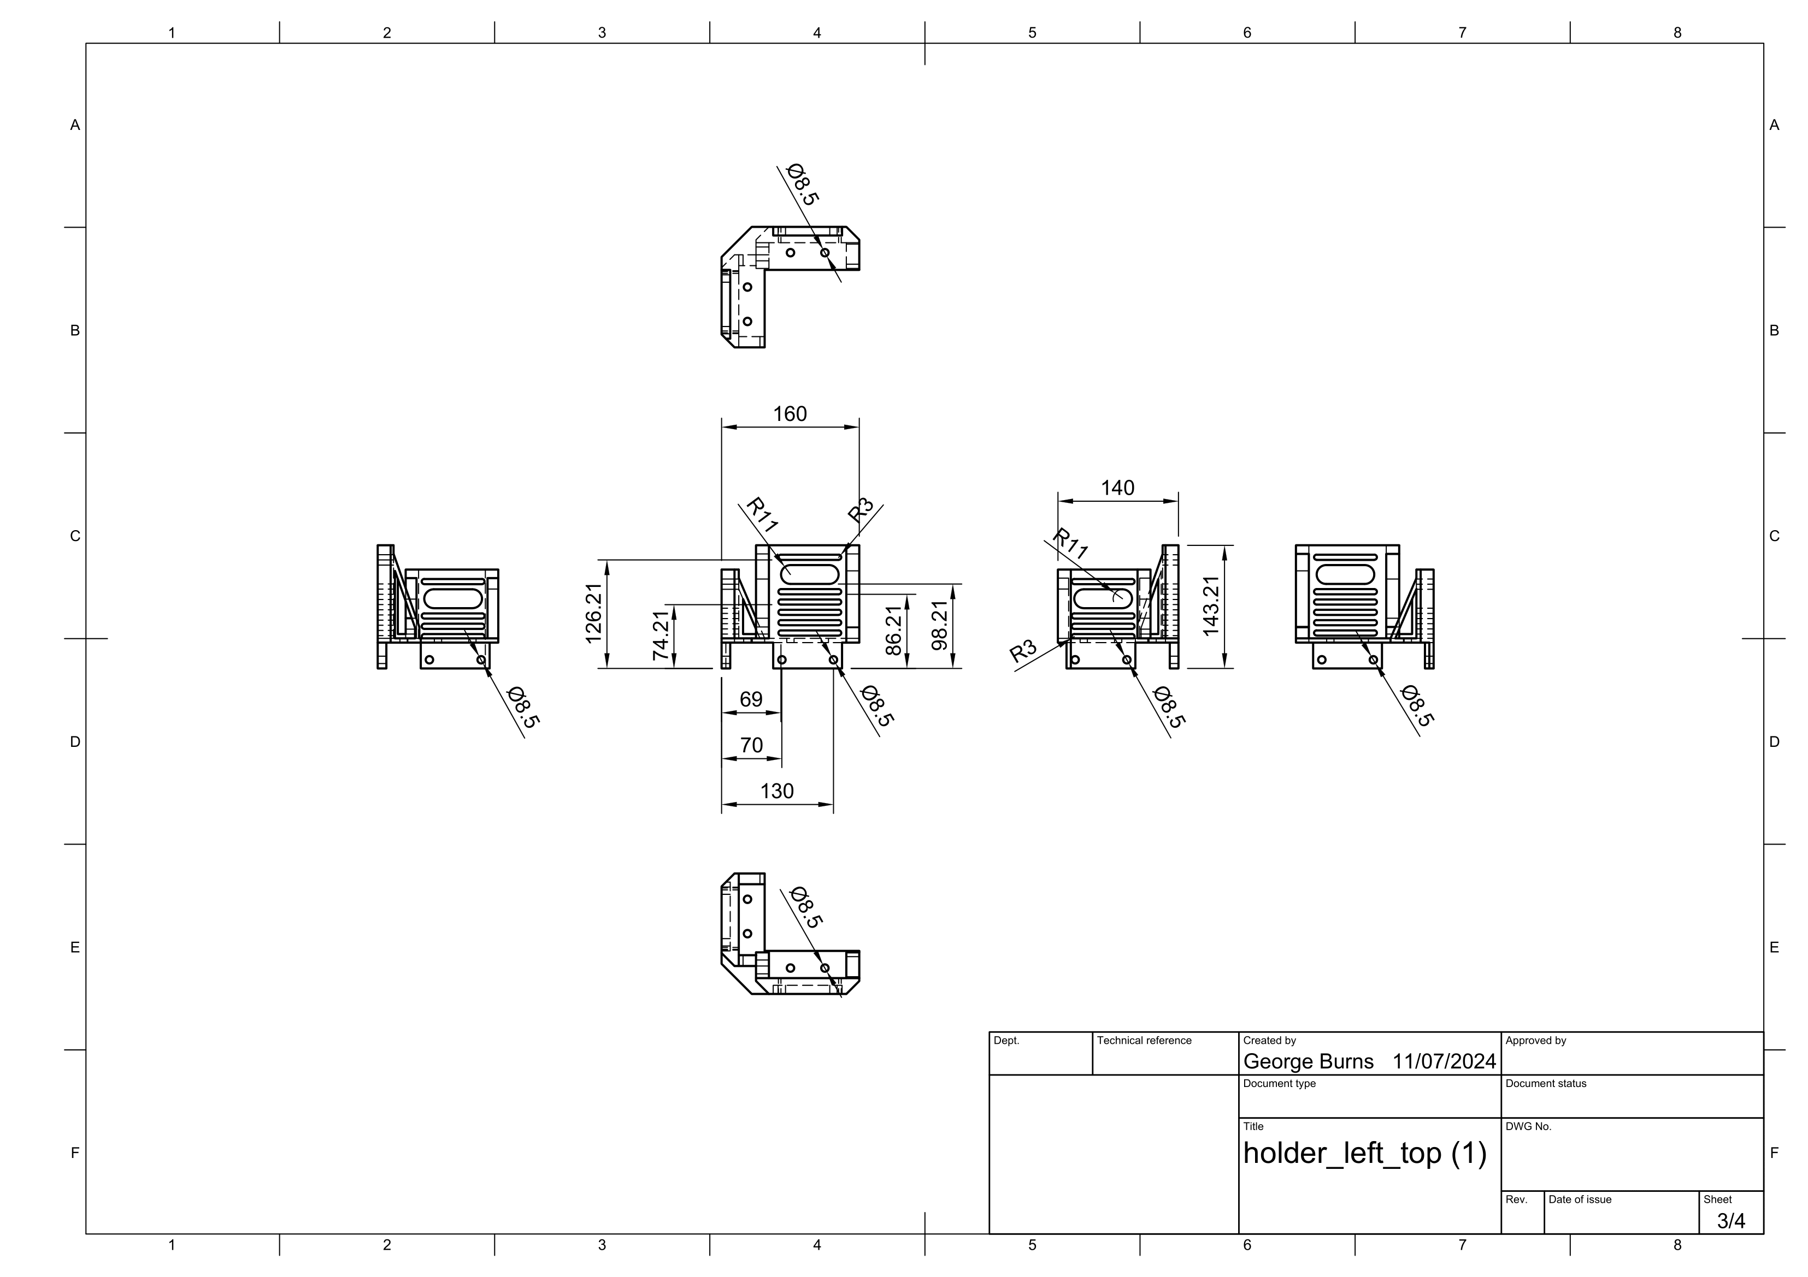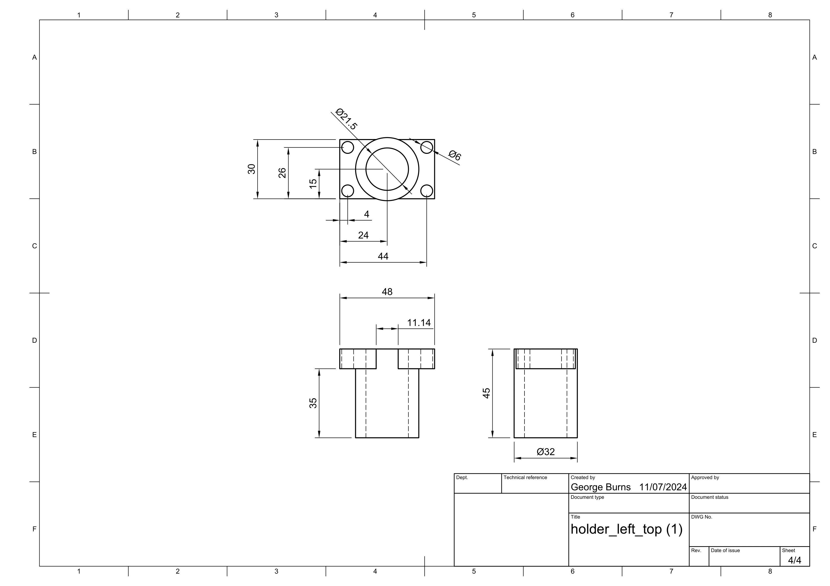

Holder Bottom Right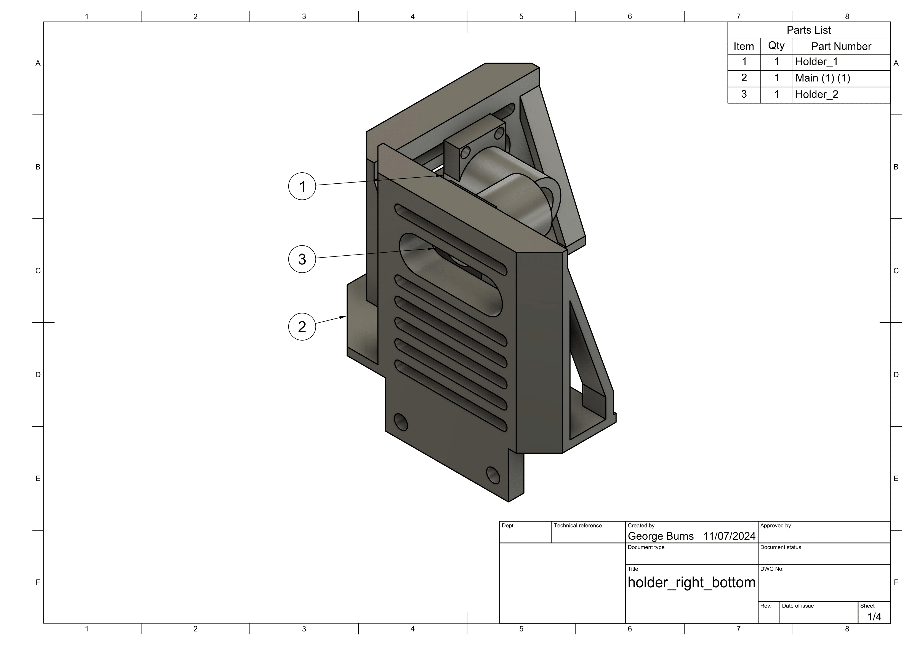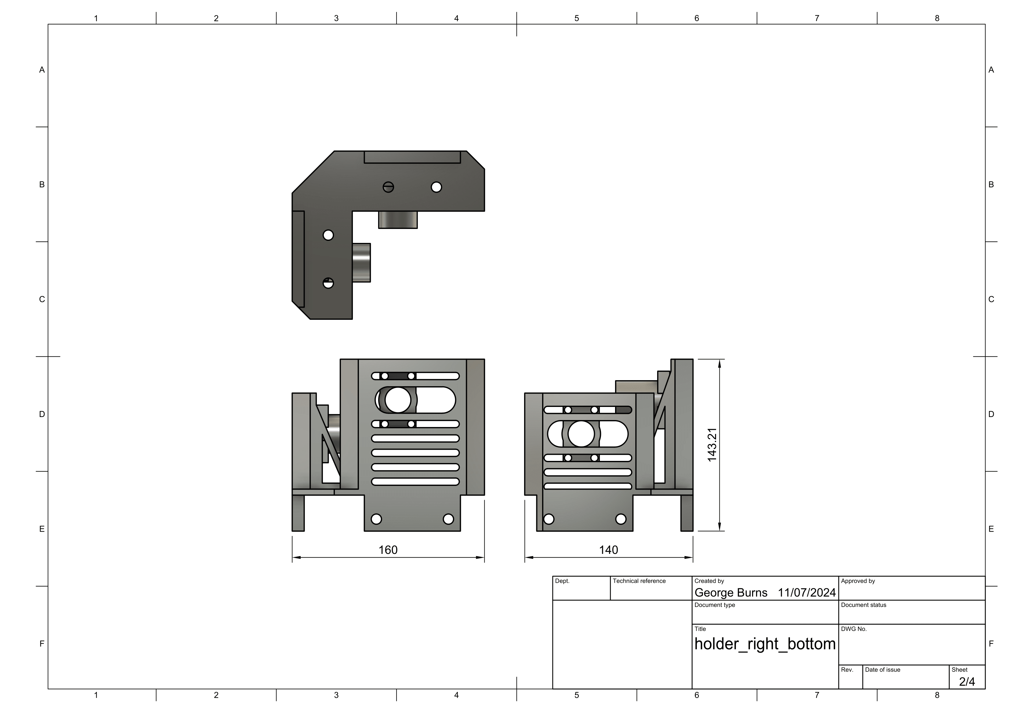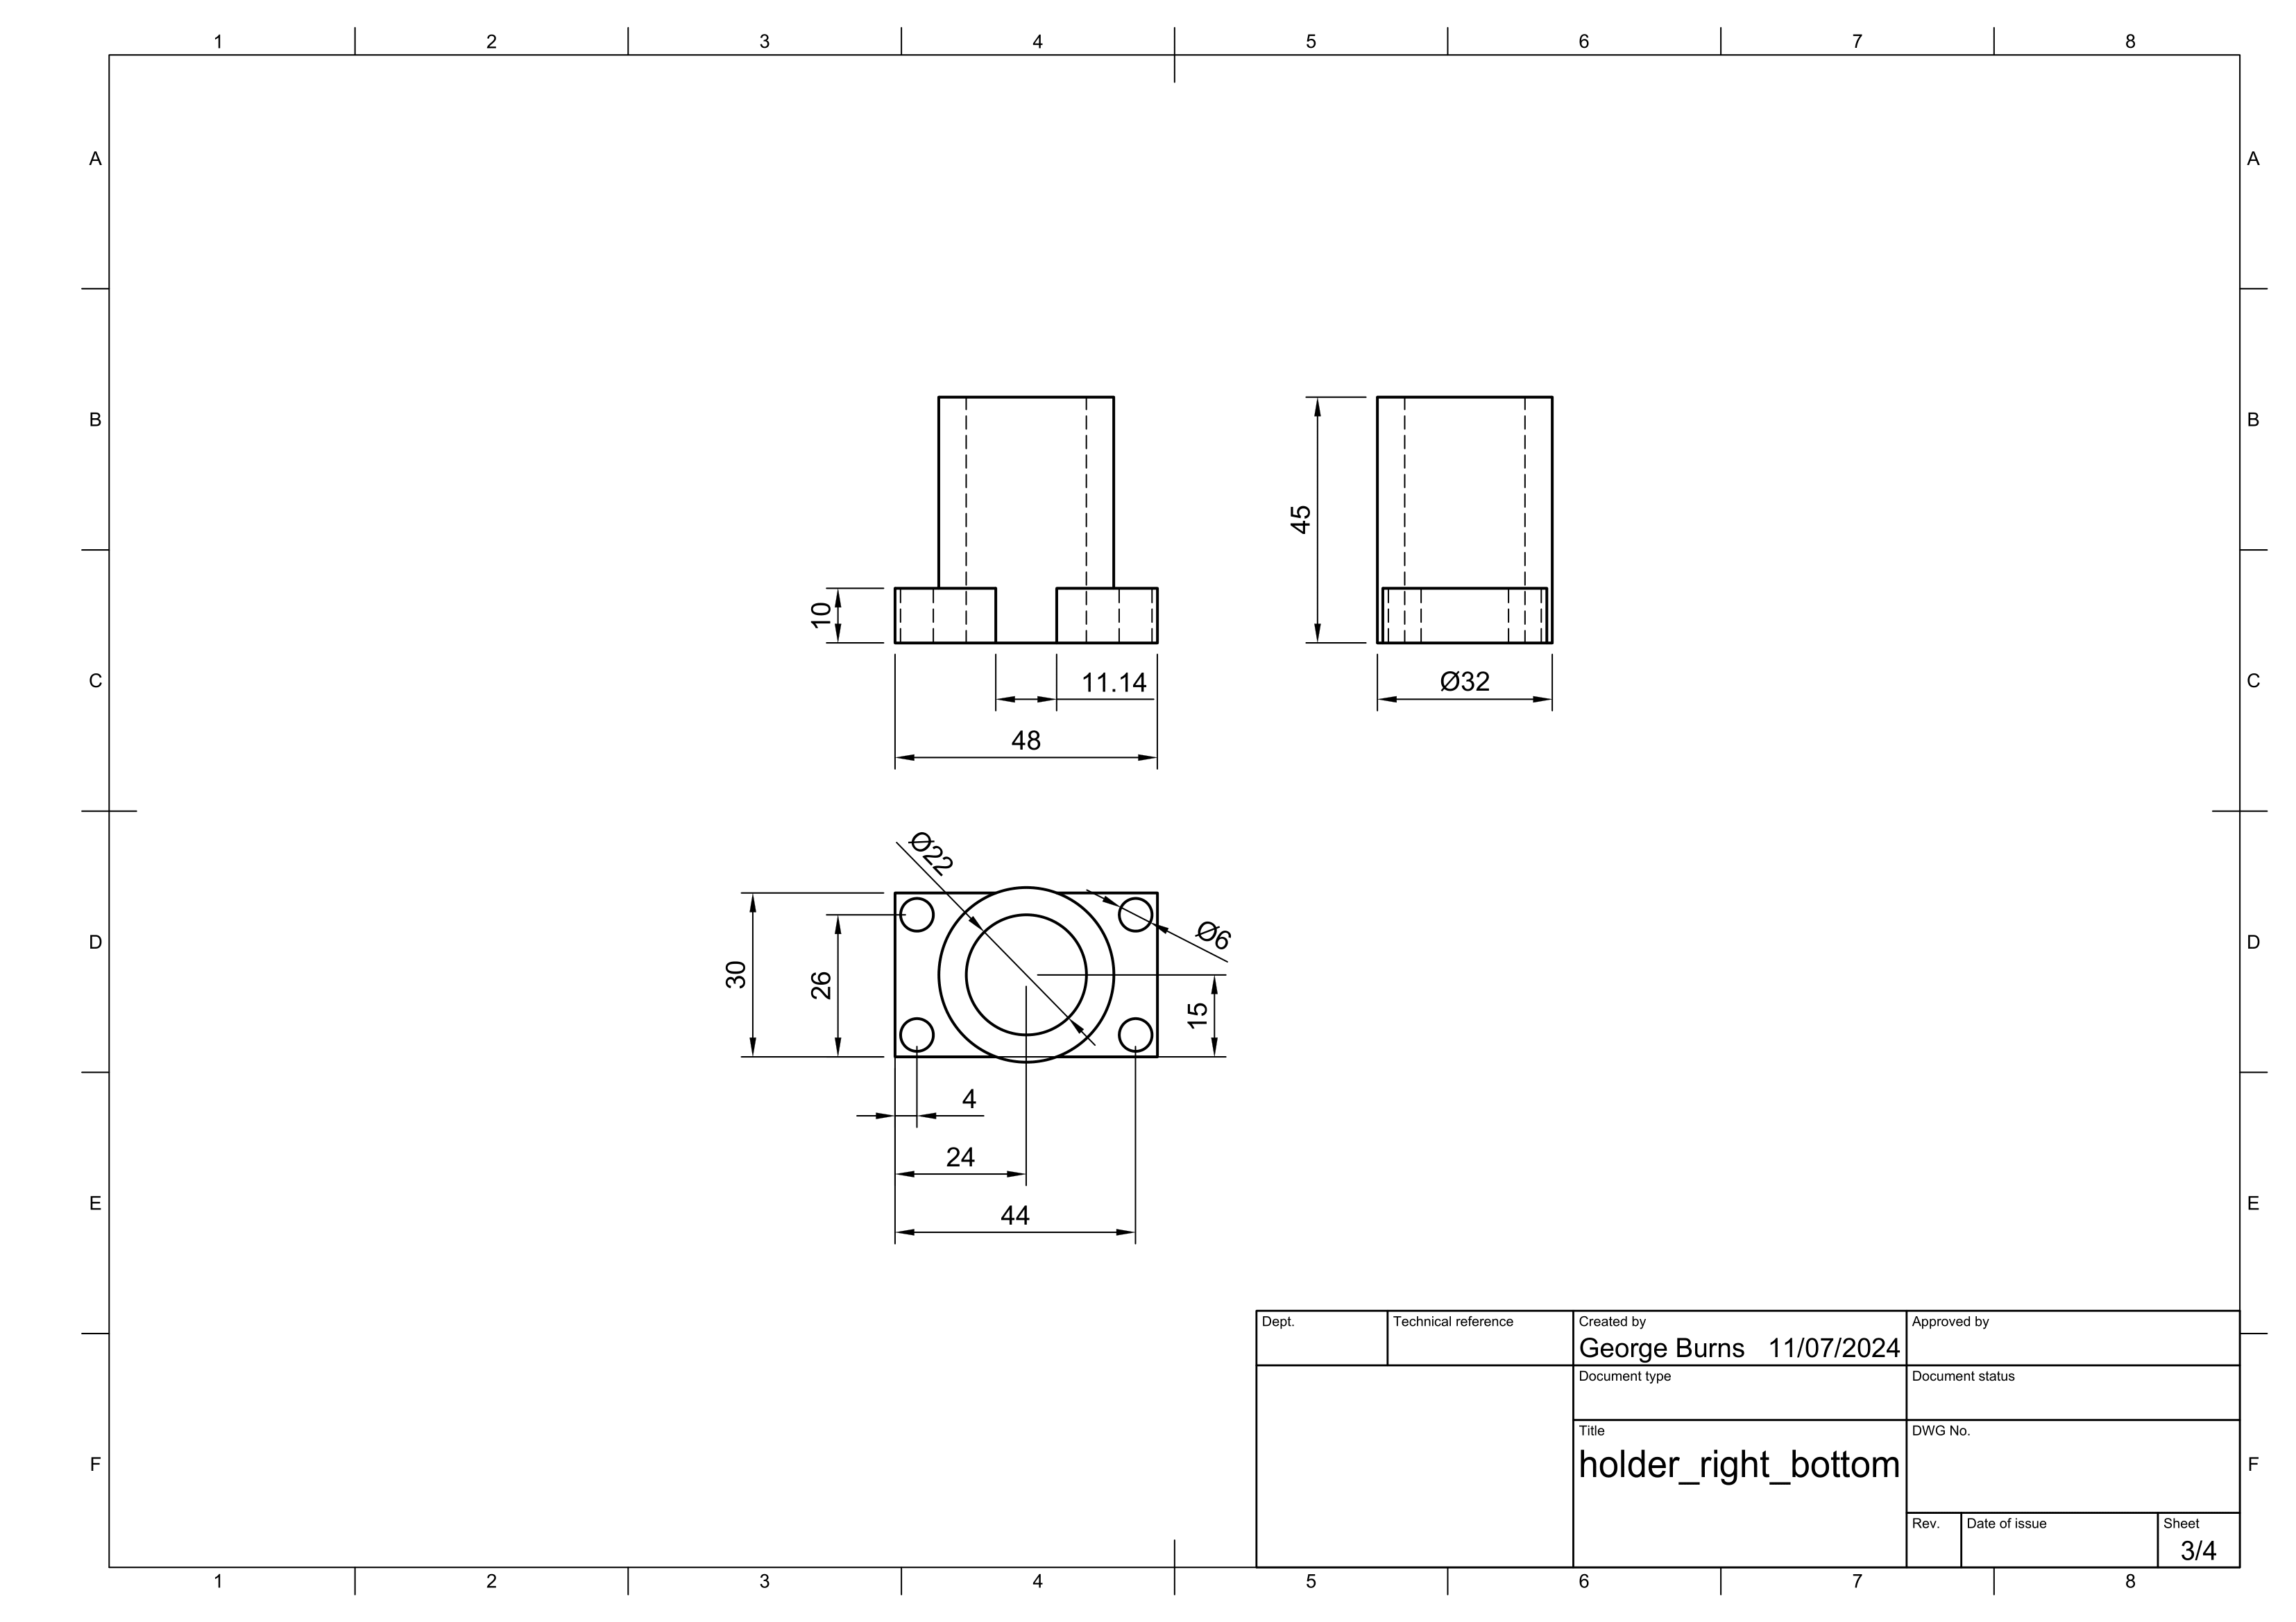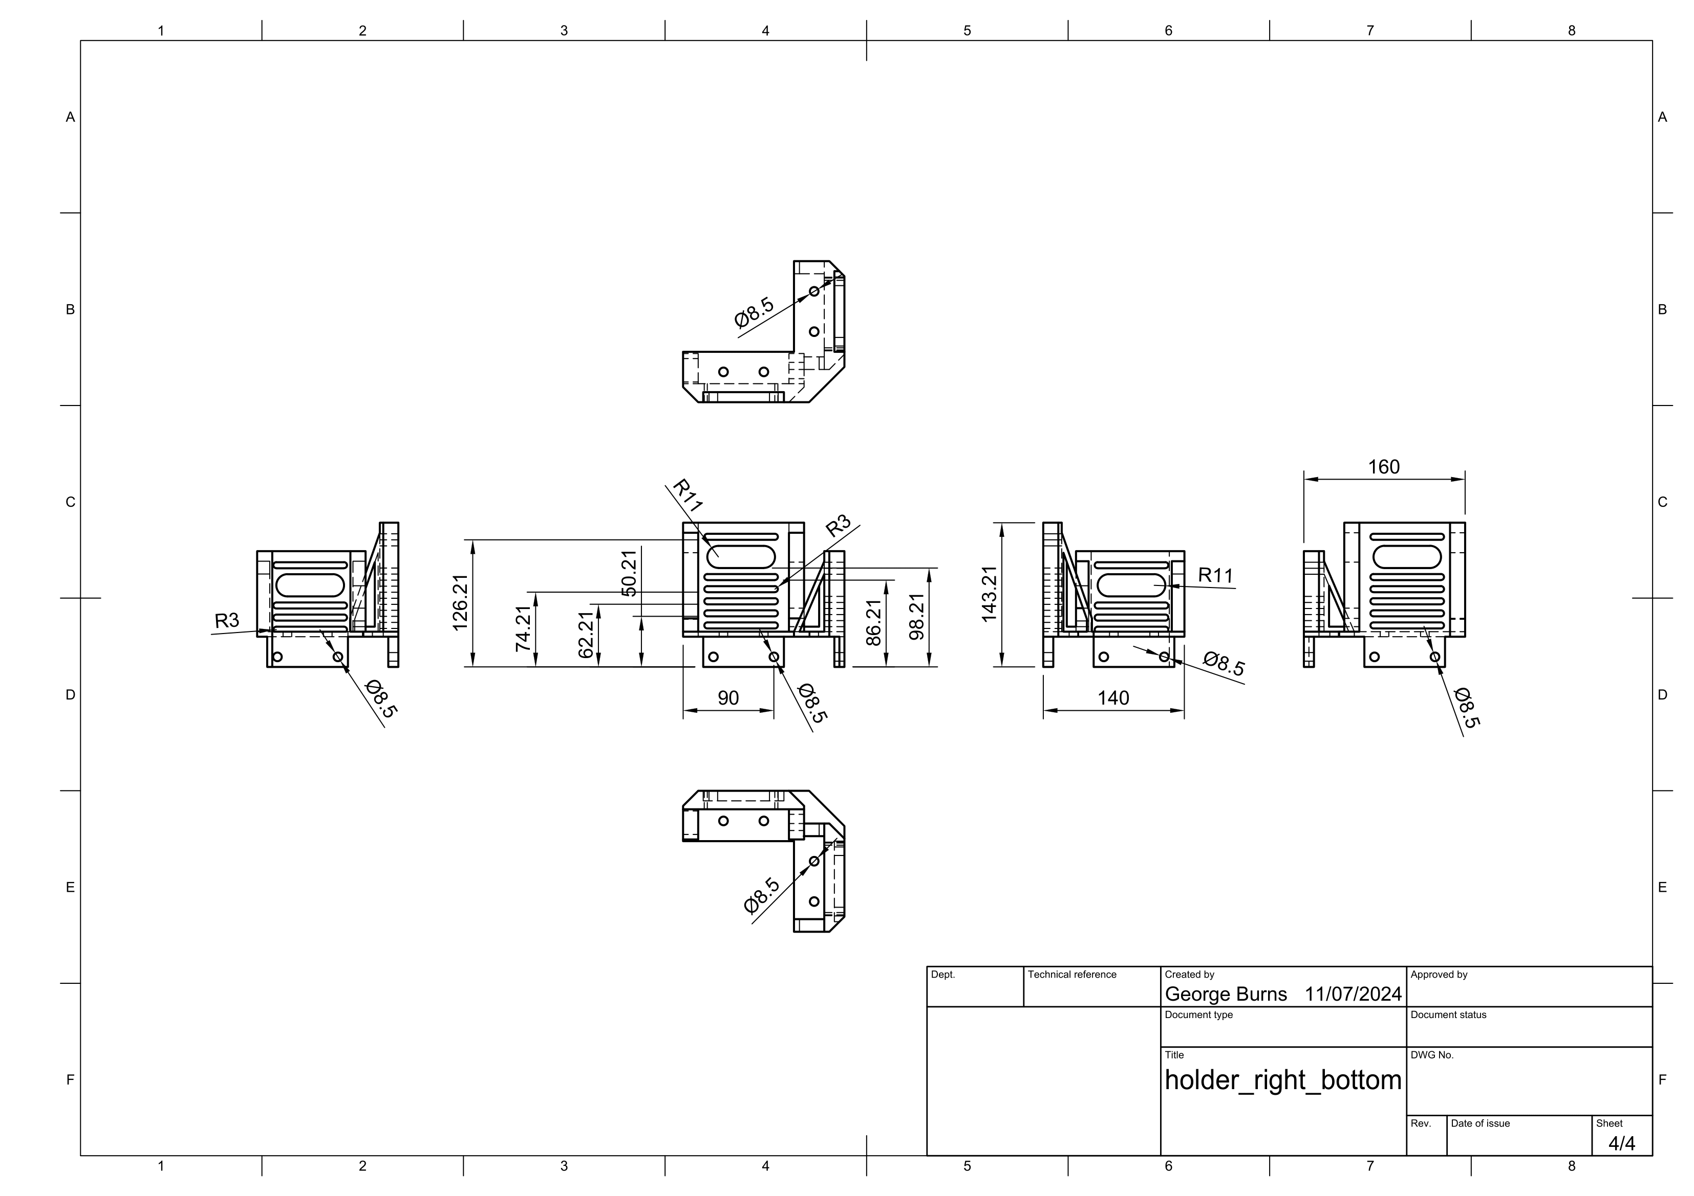

Holder top right

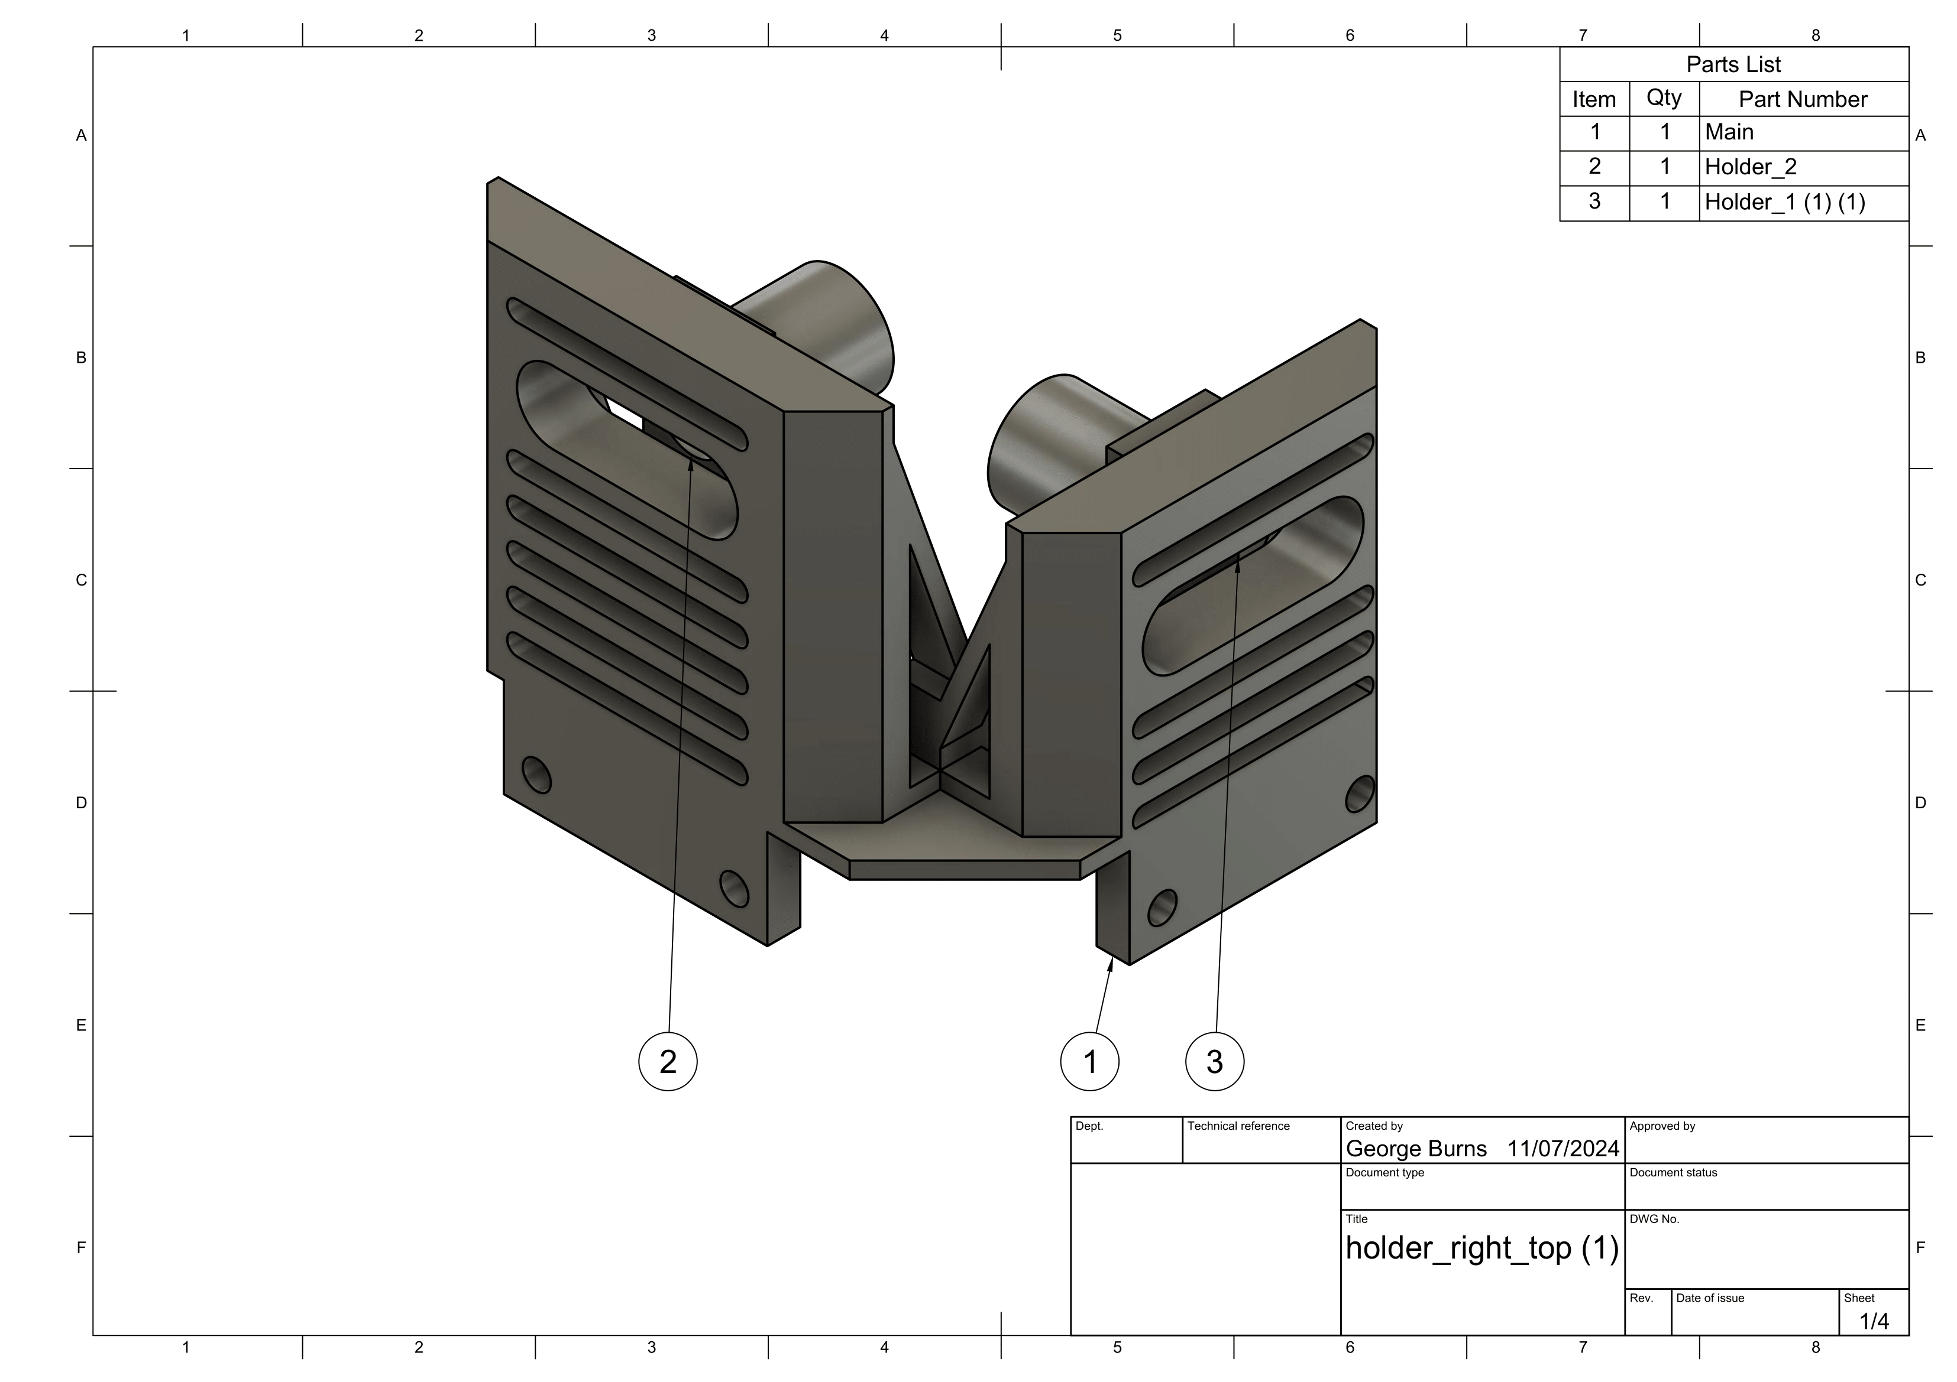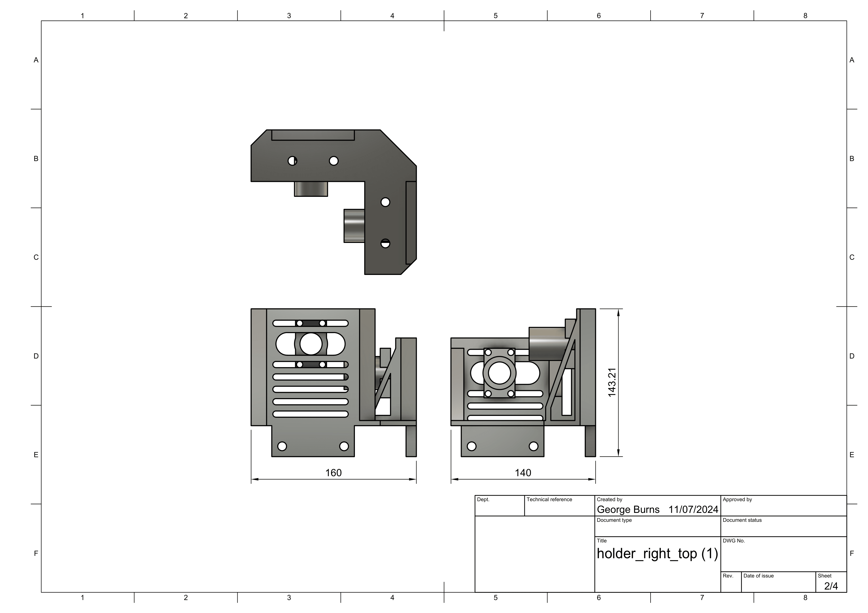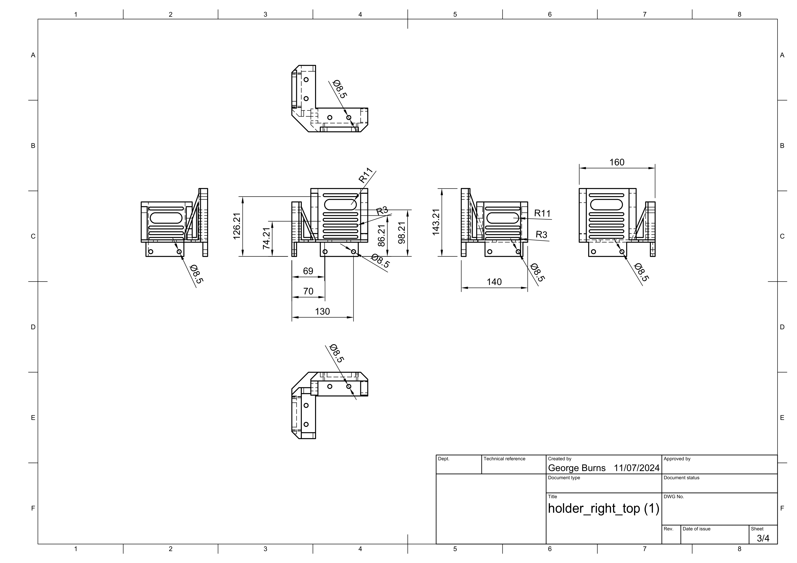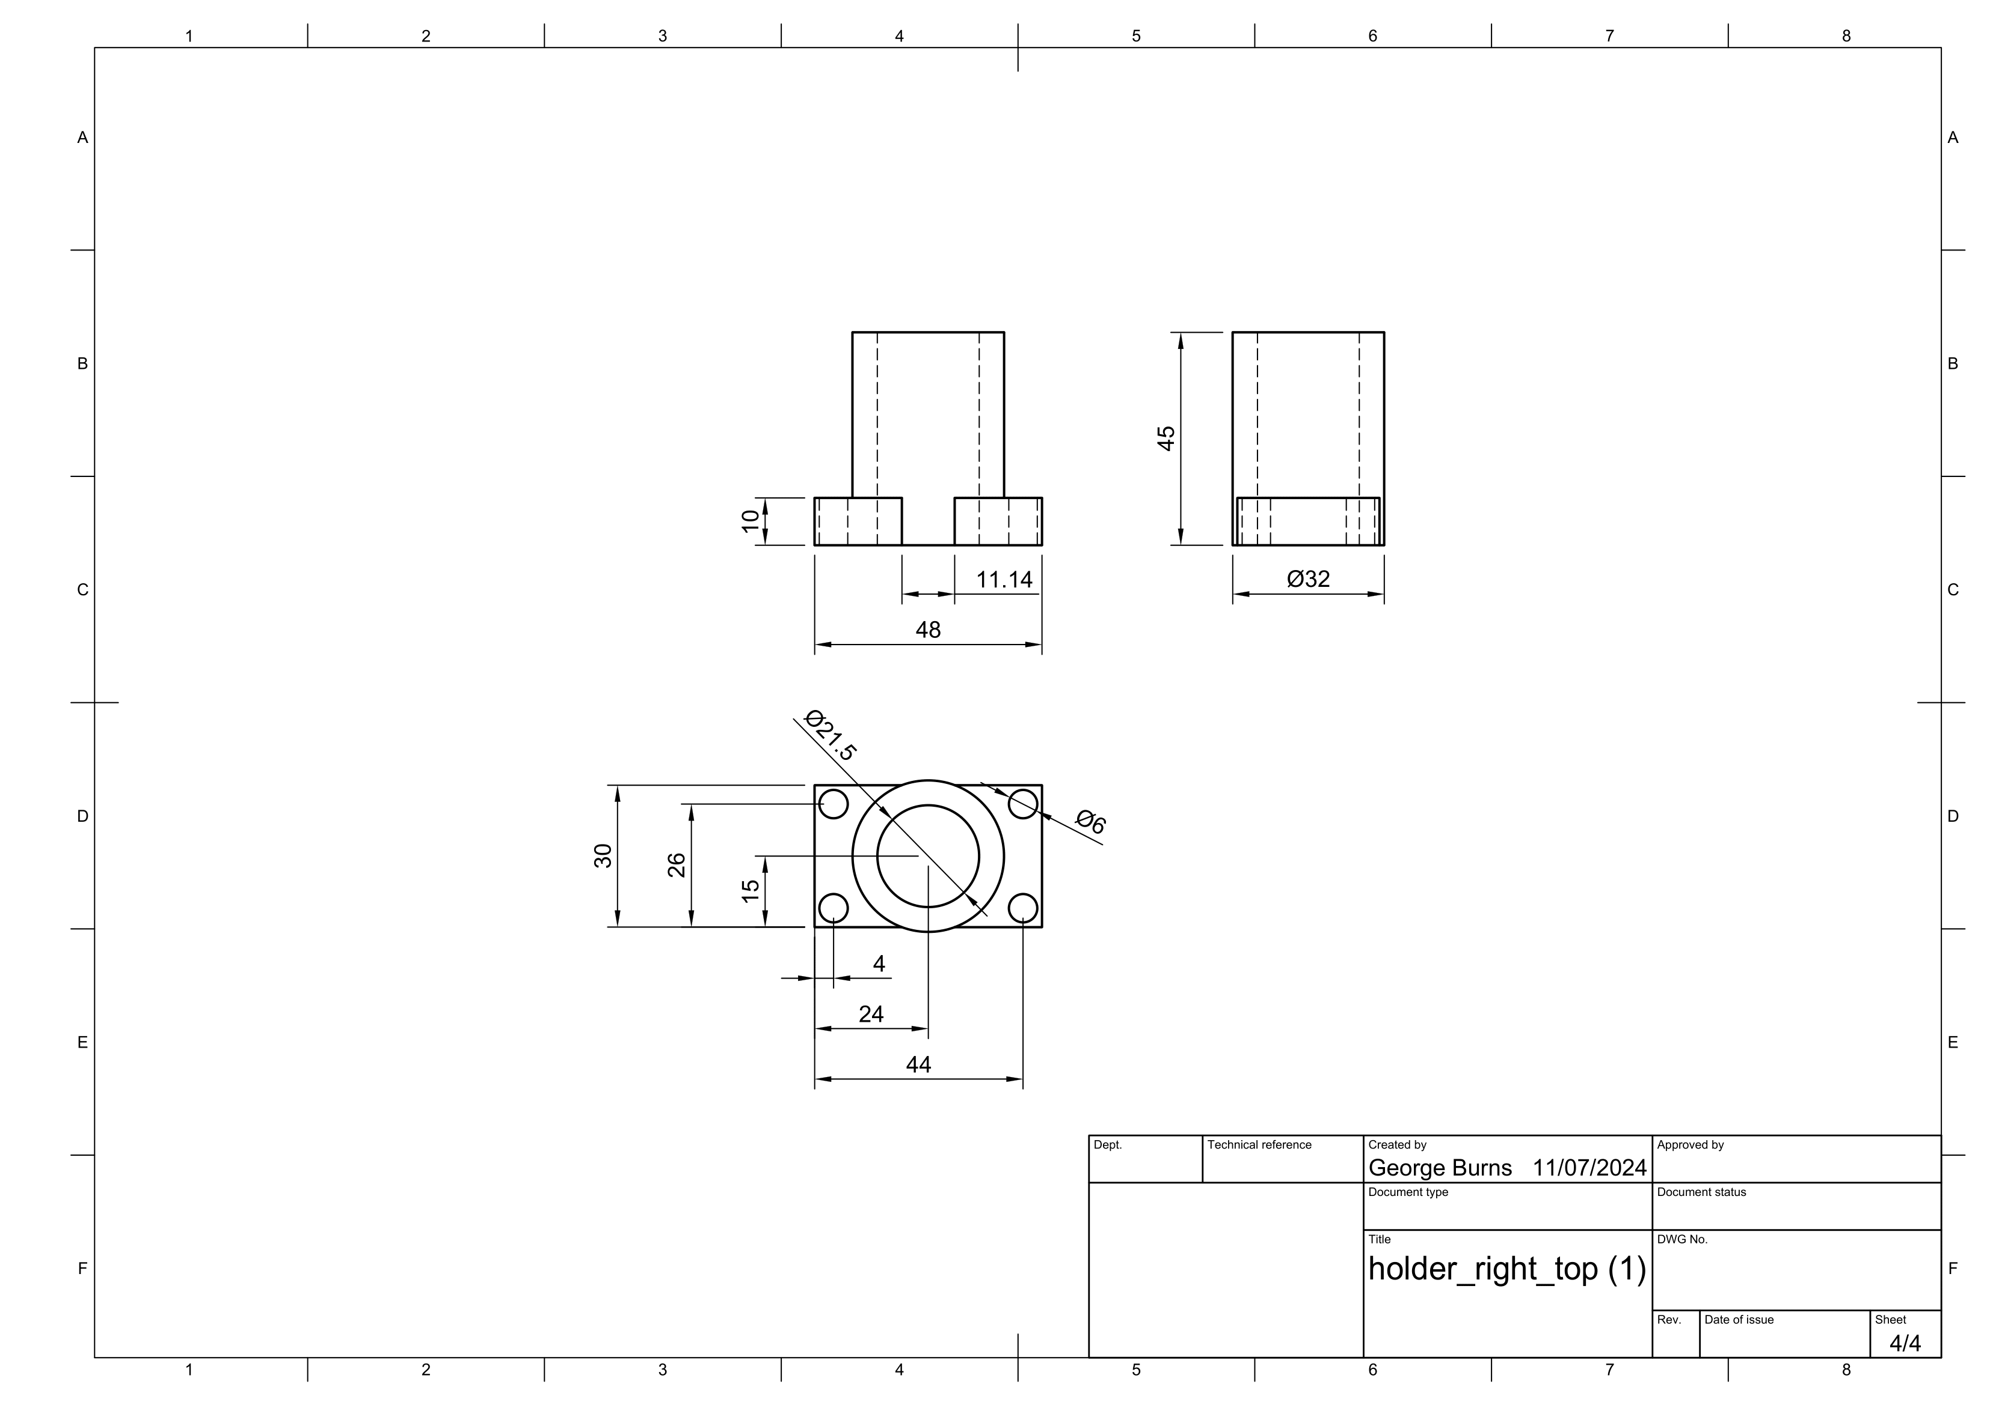

Rail holders

